**INTRODUCTION**

Hi! My name is Dan Keegan. I have been in the options business for over forty years, including over twenty years as an independent trader at the Chicago Board Options Exchange (CBOE) and the Chicago Board of Trade (CBOT). There is a common, and mistaken, perception that successful traders have a “knack” or a “feel” for it. Some sort of magical luck is involved. Nothing could be further from the truth. There is no luck or magic behind trading, it’s just hard work and discipline.

An options trader is a glamorized version of an insurance actuary. An options trader is constantly weighing the probabilities of the movement in the underlying contract that it is derived from. An option trader is also analyzing the differences among the options themselves.

I’ll walk you through those fundamentals and into advanced trading strategies. Mastery of these fundamentals and strategies is the first step to successful trading. Traders cannot expect to make money on every trade, but if they have the laws of probability on their side then they will have the wind at their backs.

**OPTIONS BASICS**

**What Are Options?**

Look at the example of six years old Susie, who has her heart set on a 1959 mint condition Barbie. This will set Susie back $200. Currently, her bank account has only $100 in it. Susie believes that she can earn at least $150 at her lemonade stand over the next twelve months. The owner, Mrs. Smith, of the vintage doll store in Susie’s neighborhood is willing to work out a deal for the Barbie doll. Mrs. Smith will sell an option on the doll to Susie. Susie will pay Mrs. Smith $25 for the right to purchase the doll at any time within the next twelve months for $220. Susie’s option on the doll is a

transferable contract.



Sixth months into the contract the value of the doll jumps to $330. The option that was purchased for only $25 would now be worth at least $110 now, wouldn’t it? The current market for the doll is priced $110 above where Susie could purchase it with her option. It would probably be worth even more than that since there is another six months left on the contract. Susie tells her situation to her twelve-year old babysitter Clare. Clare decides that she wants in on the action. Clare guarantees that Susie will be able to sell the doll to her at $295 over the next six months. Clare charges Susie a premium of $15 for that right. Susie has now locked in a profit of $35. Susie has the right to purchase the doll at $220 for which she has paid a premium of $25. Her cost basis is then $245. Clare is obligated to buy the doll from Susie for $295. $295 less the $15 premium that Clare is charging guarantees Susie her $35. This also stiffens Clare’s spine as far as holding on to her $220 option.

Eventually the value of the Barbie doll rises to $400 after the twelve-month period has expired. Susie sells out her option on the expiration date and nets $140. Susie is so happy with her experience that she has completely forgotten about purchasing the mint condition Barbie. Susie’s content to play with the fifty Barbie dolls that are currently in her basement, even though half of them are missing at least one limb. She also realizes that what works for Barbie Dolls also works with her brother Chester’s GI Joe “action figures” and her little sister Beth’s Beanie Babies. By the time Susie turns eleven her friends start babysitting. Susie decides against that career path since she already is too busy trading options.

**History of Trading Options**

The Greek philosopher, Thales of Miletus, in 322 B.C. was the first person to trade options. The first “recorded” use of options that is. I am sure that cave men traded a form of options as well. Olive trees were the main agricultural product at the time. Thales expected a bumper crop in olives, so he correctly surmised that there would be a huge demand for olive presses at harvest time. Thales went around to the olive press owners and paid a premium for the use of their presses at harvest time. He was correct in his prediction on the olive harvest and was able to resell his options to the olive farmers at a handsome profit. If there was a drought then Thales would have been out only the premium that he paid, not the entire value for the purchase of the olive presses.



From 1700-1733 there was an organized market in the trading of options in London. They were declared illegal until 1860. When you cannot understand something, then ban it! Some things never change. In 1872 Russell Sage, a New York financier, introduced options to the OTC market.



Modern day options trading began with the trading of warrants. Warrants give the holder the right to purchase securities (usually equity) from the issuer at a specific price within a certain time frame. Warrants were often included in a new debt issue as a "sweetener" to entice investors. Warrants were pretty much ignored and not held in high regard until Edward O. Thorp came along.



Thorp first made a splash with his book *Beat the Dealer:” A Winning Strategy for the Game of Twenty-One”*. He also published “*Beat the Market: A Scientific Stock Market System”.* The latter book dealt with the pricing of stock warrants. Thorp found that the pricing of these warrants was all over the board. He took advantage of this with the first stab at theoretical pricing. His *methodology* was *crude,* but the *results* were *revolutionary*. Since the number of warrants issued by a company was limited, it was difficult for the public to utilize Thorp’s theories on pricing. This led to the concept of publicly traded options on equities. Unlike warrants, options are issued by an exchange, not a firm.

The most renowned options pricing model is the *Black-Scholes Model*. Fisher Black and Myron Scholes developed the model. Robert Merton, a professor at MIT in continuous time finance, publicized their work in a paper that he published in 1973. Merton also incorporated the work of our old friend Edward O. Thorp and others into his work. This netted a Nobel Prize for Merton as well as Scholes.

There have been countless other pricing models since Black-Scholes although all of them use the same inputs to decipher the relative value of options. You do not need to know what is behind the curtain of these models to become a successful trader. I will not delve into them very deeply. I will teach you how to fly the airplane, not how build it.

In 1973, partially due to the work of Merton, Black and Scholes, the first listed options exchange was founded in Chicago. The options that were first listed on the Chicago Board Options Exchange (CBOE) were options on stocks. Originally only call options were listed. What is a call option?

A *call option* on stocks is an agreement that gives a trader the *right*, but not the *obligation*, to *go long stock* at a *specified price* within a *specific, time frame*.

A *put option* on stocks is an agreement that gives a trader the *right*, but not the *obligation*, to *go short stock* at a *specified price* within a *specific, time frame*.

These options *derive their value from the underlying* stock, exchange traded fund (ETF) or futures contract. That is why they are called *derivatives*. While call options derive their value from the value of their underlying, stock they are not the same thing as stock. Call options expire after a certain date and do not pay a dividend. So why do people trade them?

Options give you leverage, combined with a defined risk. When I was younger, I worked at a slaughterhouse loading trucks. I was 6’ tall and all of 155 pounds, and I had no problem lifting 200 lb. hindquarters. The older guys there had taught me how to hoist the hindquarters on my back and simply use leverage. *Leverage makes you bigger* than you are.

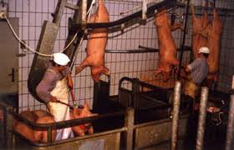

OK, if *leverage* is a *major advantage* of being *long options*, *what is* the biggest *disadvantage* of being *long options*?

The answer is *time*. Remember I said that a call option gives you the right to acquire a long stock position within a specified time. Well, once that time has expired, so has that option. *Options* are a *wasting asset*. When you buy a car, it is worth less a mile down the road than it was when you bought it. The value of the car is constantly decaying. That characteristic is a *liability* when you are *long options* but an *asset* when you are *short options*. When a short options positions go out worthless, then it is Mardi Gras, Chinese NewYear, Carnival and Oktoberfest all rolled into one. That is the never, ending battle amongst options traders. Time vs. Leverage.









**Market Fundamentals**

Whenever you have *bought more than you have sold*, you are *net long*; whenever you have *sold more than you have bought*, you are *net short*. When you have *bought and sold an equal amount* then you are *flat*. When you have *bought* an option, or any other instrument for that matter, and *have not yet sold it* out, you are *long* that option. Conversely, when you have *sold* an option and have *not bought* it *back*, you are *short* that option.

**Fundamentals of Options**

The previous chapter covered the introduction of listed call options on the CBOE. Soon after the birth of the CBOE, the American Stock Exchange (AMEX), the Pacific Stock Exchange (P-Coast) and the Philadelphia Stock Exchange (Philly) soon launched competitive options exchanges. In 1982 listed options began to be traded on the Chicago Mercantile Exchange (CME) and the Chicago Board of Trade (CBOT). There are currently twelve different twelve exchanges that trade listed equity options. There are additional commodity exchanges as well. After those early exchanges had demonstrated a market for call options, they launched a new options product on a trial basis. The trial product was listed *put* options on stocks. *Put options* are the *mirror image* of *call options*. Whereas long call options give you the right (but not the obligation) to establish a long stock position at a certain level within a specified time frame, long *put options* give you the *right* (but *not* the *obligation*) to *establish* a *short stock position* at a *certain level* within a *specified time frame* at a mutually agreed upon price. By 1980, puts were no longer used on a trial basis. They became an integral part of the options business.

Notice the terminology. You are *calling* the *stock home,* or you are *putting* the *stock on the market*. Going *long* a *call* gives you the opportunity to go *long* the *stock*. Going *long* a *put* gives you the opportunity to go *short* the *stock*. I hope that this lesson in mnemonics helps you to distinguish between a call and a put, and now that you know the definitions of calls and puts, it is important to describe each type of option.

We talked earlier about long call options giving you the right, but not the obligation, to go long stock at a certain price level within a specific time frame, and long put options giving you the right, but not the obligation, to get short stock at a certain level within a specific time frame. What is that certain price level?

That *certain price level* is called the *strike price*. The *strike price* is the *price* at which the *call buyer* goes *long* the *underlying stock* or the *put buyer* goes *short* the *underlying stock.*

Every option traded has a strike price. Every stock traded in the options market has puts and calls at several different strike prices. The market is generally more *active* in those *strike prices* that are *closest* to the *current price* of the stock. For example, an IBM 20Sep 143 call is an active option when IBM is trading at 143.45.

Now when it is said that a long option gives you the right, but not the obligation, to establish a long or short stock position it is about the right to *exercise* an option*.* The *long position* in an *options* contract has the *right* to *exercise*, or initiate, a transaction at any time before the contract expires. *Upon exercise* a trader with a *long call* position will go *long* the *stock* at the *strike price*, and the trader with a *long put,* position will become *short* the *stock* at the *strike price*.

While a trader with a long options position is in control of their destiny, the trader with the *short options position* is at the mercy of the market and can be *assigned* to complete the transaction. The *short call* position is *obligated* to go *short* the *stock* at the *strike price* when they *receive* an *assignment notice*. The trader with a *short, put* position has an *obligation* to go *long* the *stock* at the *strike price* when they *receive an assignment notice*. *Long* options positions have *rights* while *short* options positions have *obligations*.

What does the word exercise connote? It is an active role requiring independent action. On the other hand, what does the word assignment connote? It is a passive role where you are the recipient of somebody else's action.

Just as there is a *long for every short* there is an *exercise for every assignment*. Does this mean that when you exercise an option, the trader that you originally purchased that option from is assigned? No, (although it is possible, but highly unlikely, if the call seller is still short calls) since assignment is random.

The clearing of each trade has been guaranteed by the establishment a general clearinghouse for options. It is called the Options Clearing Corporation (OCC). The CME and ICE are the major clearing corporations for options on futures.

A *clearinghouse* is an institution that *guarantees* that *trades clear correctly*. The clearinghouse guarantees that each customer is given credit for every trade that is completed and then the money and the existing positions are properly designated to each trader’s account. If one of the traders is bankrupt the trade is still good. Even if one of the clearing firms goes bankrupt the trade is still good. Each clearing member makes a financial commitment which incentivizes risk management.

Once you have established a long or short position, then you are thrown into the general clearinghouse hopper. For every option contract that is exercised, the OCC randomly assigns a trader who is short that same contract to fulfill the obligation to take (as in the case of puts) or make (as in the case of calls) delivery of the stock. *Exercise* and assignment *can occur* at *any time* prior to the *expiration date* for *American* style *options*. *Exercise* and assignment can only occur at *expiration* for *European* style *options*.

OK, when should a trader who is long an option exercise that option and when should a trader who is short an option, expect to receive an assignment notice? At *expiration* you will *exercise* a *long* option when that option is *in-the-money* (*ITM*). Look at FB, which is trading at 287.00. Call and put options trading with a strike price of 287 are *at-the-money* (*ATM*). When you are long a FB 287 call, or a FB 287 put you would gain no advantage in exercising the call or put versus going long or short FB in the open market.

When FB is trading at 289.52, your FB 287 call is looking better with FB trading *above* the *strike price*. It is therefore an *ITM call*. When you exercise the call, you go long FB at 287, 2.52 points below where FB is trading in the open market.

When FB is trading at 284.37 it is trading *below* the *strike price* of your FB 287 call. It is therefore an *out-of-the-money* (*OTM*) call. By exercising the call, you would become long FB at 287.00. That would be 2.63 points above where you could purchase FB in the open marketplace. Not exactly a shrewd move.

Now look at how those same examples affect puts: When FB is trading at 284.37, it is trading *below* the *strike price*. It is therefore an *ITM put*. By exercising the put you would be shorting FB at 287.00. That would be 2.63 points *above* where you could short FB in the open market. Now that is a shrewd move.

When FB is trading at 289.52, it is now trading 2.52 points *above* the *strike price*. It is therefore an *OTM put*. By exercising the put you would be shorting FB at 287.00. That would be 2.52 points *below* where you could sell FB in the open market. Anyone’s career as an options trader will be brief if they keep doing something like that.

What you can surmise from these examples is clear. At *any time that an option is ITM* there is an *incentive for the trader* who is *long* that option to *exercise* and, consequently, the *potential* for a trader who is *short* to be *assigned*. While the long trader might choose not to exercise for whatever reason, the short has no control and must be prepared to fulfill their obligation for assignment. Remember the long has rights and the short has obligations.

OK, now on to that *specific time frame,* when the long options position can choose to exercise that option; that’s the time between when the option trade is transacted up to the *expiration date* of the option contract. Every option contract has a date on it. That is when the contract expires. When the FB 287 calls were mentioned before, they really should have been called FB 19Mar21 287calls.

What does 19Mar21 signify for FB 19Mar21 287call? 19Mar21 is the conclusion of the *expiration cycle*. The cycle ends on March 19th, 2021. An expiration cycle was nine months long when I started and every three months a cycle would end and be replaced by a new cycle three months out. Now there are monthly, weekly, and daily options. There are options cycles that are dated over a decade into the future. Any trader who is *short a call or long a put* has the *potential to become short the stock* at some time in the future. When you are *long a call or short a put* you have the *potential* to become *long* the *stock* at some time in the future. This will almost certainly happen when either of those options wind up being ITM at expiration. OK, it is now time for a small review. *OTM options disappear* for good at the *end* of the *expiration cycle*. *ITM options* continue to *live on* as they *morph into either long or short stock.*

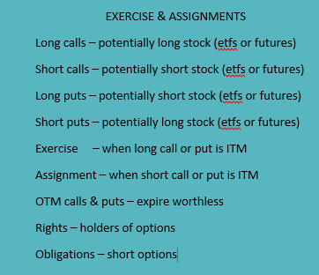

The last fundamental covered is called *premium*. That is the *price where the options transaction takes place*. *Premium* is comprised of either *expiration* (intrinsic) *value* or *time* (extrinsic) *value* or a combination of both. Look at three different calls and three different puts in NVDA, when NVDA is trading at 181.80.

The premium for the 18Oct19 100 calls is 81.80. If NVDA is trading at 181.80 at the close of the expiration cycle, those calls will be worth 81.80. Their premium is therefore comprised entirely of expiration value. The premium for the NVDA 18Oct19 190 calls is 4.05, with 33 days remaining until expiration. If NVDA is trading at 181.80 at the close of the expiration cycle those calls will expire worthless. Their premium is therefore comprised entirely of time value. The premium for the NVDA 18Oct19 180 calls is 8.50. If NVDA is trading at 181.80 at the close of the expiration cycle those calls will be worth 1.80. The remaining 6.70 of premium is time value. Their premium is comprised of both expiration value and time value.

The premium for the 18Oct19 NVDA 240 puts is 58.20. Should NVDA be trading at 181.80 at the close of the expiration cycle those puts will be worth 58.20. Their premium is therefore comprised entirely of expiration value. The premium for the NVDA 18Oct19 160 puts is 1.43. Should NVDA be trading at 181.80 at the close of the expiration cycle those puts will expire worthless. Their premium is therefore comprised entirely of time value. The premium for the NVDA 18Oct 185 puts is 8.75. With NVDA trading at 181.80 at the close of the expiration cycle those puts would be worth 3.20. The remaining 5.55 of premium is time value. Their premium is comprised of both expiration value and time value.

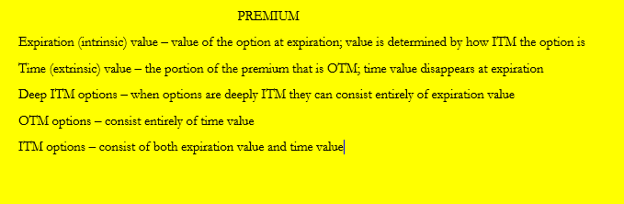

**Leverage Regarding Stock vs. Options**

You begin by *comparing* the use of *options on stocks relative* to the use of *stock by itself*. Start by going long 500 shares of AAPL at 218.75. That trade will eat up $109,375.00 of your trading account. If you margin your purchase it will eat up only $54,687.50 (REG T 50%) of your account. Of course, if the trade goes against you, you will need to keep throwing more money into your account if you want to stick with the trade. What happens when AAPL runs up to 232.50. over the next two months? That results in a profit of $6,925.00. A return of 75.98% if you are margined! You cannot beat that! Who needs those stinking options anyways?

GRAPH1

Long AAPL stock

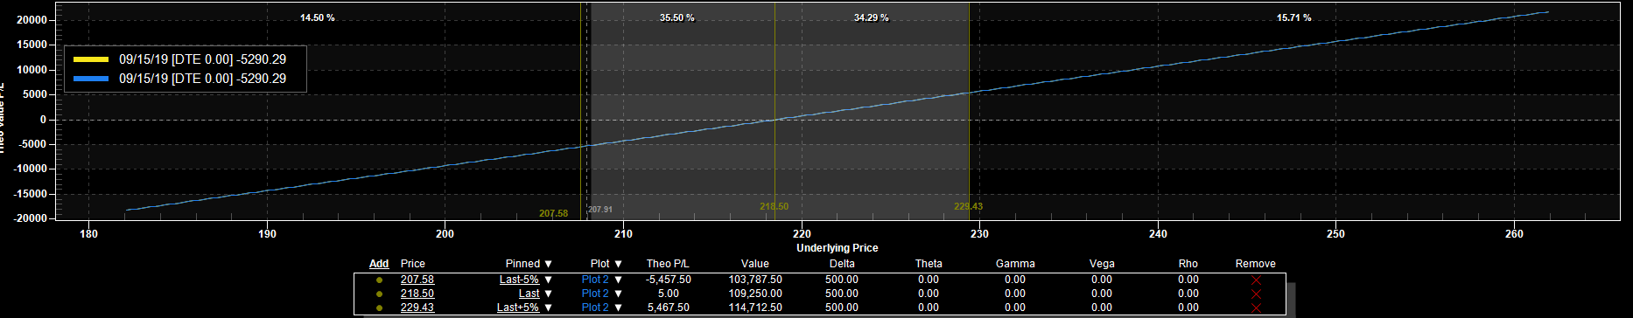

Instead of going long AAPL stock you go long twenty AAPL 15Nov19 225 calls for 6.75. That drains your account of $13,500. You now potentially have control of 2,000 shares of stock. What happens if AAPL runs up to 235.50 over the next two months? Your 15Nov19 225 calls will be worth 10.50 for a profit of 3.75 per call totaling $7,500, an APR of nearly 333%. There are two advantages here. One is that $13,500 is the maximum amount of money that can be lost. The other is that you can control four times the number of AAPL shares for less than one quarter the amount of money (16X LEVERAGE). Each call option potentially represents one hundred shares of AAPL. Going *long call options in lieu of stock* gives you *greater leverage* on the *upside* while *defining* your *downside exposure*.

GRAPH2

Long 20 4Nov19 AAPL 225 calls

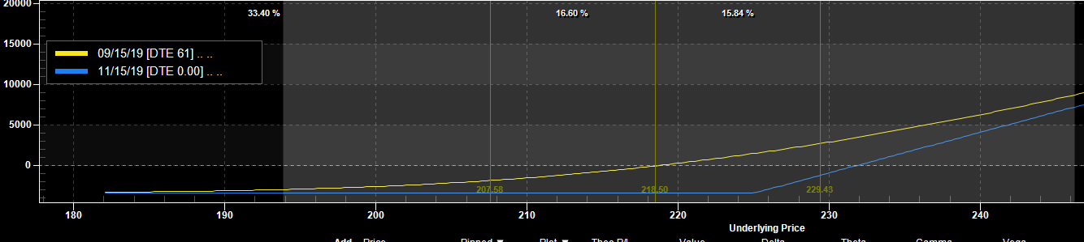

Compare *shorting stock relative* to *purchasing puts*. To short stock you need to come up with 150% of the price of the stock. You short five hundred shares of TWTR at 42.63. That trade requires a capital outlay of $31.972.50. What happens when TWTR declines down to 35.02 over the next two months? A profit of $3,805 occurs, which is a greater than 71% APR. Dare I say, “Who needs those stinking options anyways?”

GRAPH3

Short 500 shares TWTR

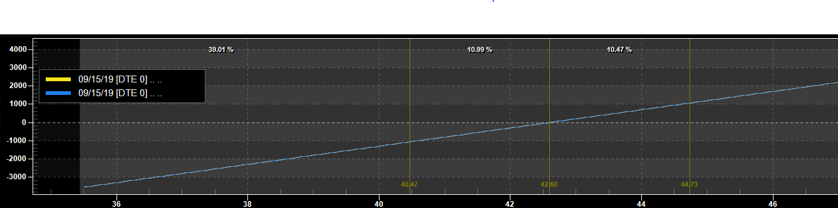

Now you can look at going long 20 TWTR 15Nov19 38 puts for 1.30. That would put a dent in your account to the tune of $2,600. What happens when TWTR declines down to 35.02 over the next two months? The puts would be worth 2.98 for a profit of 1.68 per contract, totaling $3,360, which is an APR of 775%! There are two advantages here. One is that $2,600 is the maximum amount of money that can be lost. The other is that you can control quadruple the number of TWTR shares for 8.1% of the capital commitment. Each put option potentially represents one hundred short shares of TWTR. Buying put options in lieu of shorting stock gives you *greater leverage* on *downside* moves while *defining* your maximum loss when the stock rallies.

GRAPH4

Long 20 TWTR 15Nov19 38 puts

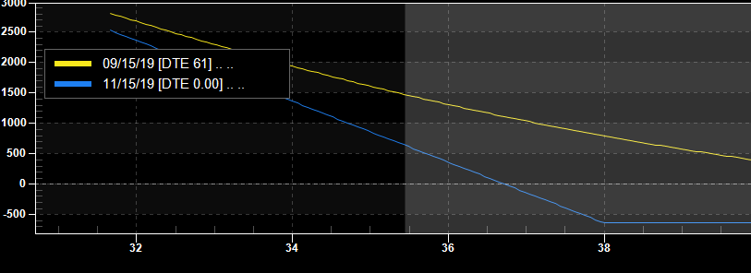

**Combining Stock and Options**

Look at a strategy that combines being both long 500 shares of stock, Wells Fargo (WFC) at 48.92 and being long 5 WFC 18OCT19 50 puts at 1.85. This is a bullish strategy.

When you are straight long the stock then the worst, case scenario is for WFC to go to zero, resulting in a loss of $24,460. The best, case scenario for that trade is one of unlimited profits to the upside.

GRAPH5

Long 500 shares WFC at 48.92

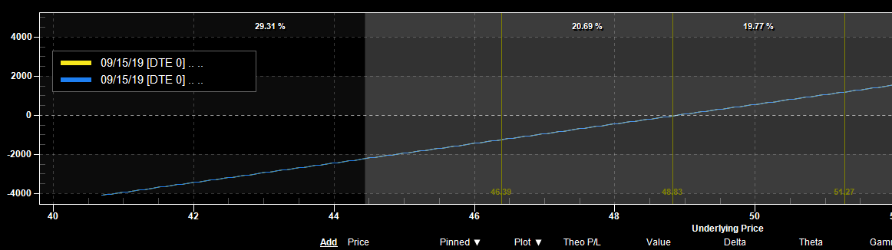

When you are straight long the puts then the worst, case scenario is for WFC to stay at 50.00 or go higher, where the puts expire worthless, resulting in a loss of $925. The best, case scenario is for WFC to go to zero, resulting in a profit of $28,490. Being long the WFC 18Oct19 50 puts gives you the right to short WFC at 50.00. Since you went long the WFC puts at 1.85 your break-even point occurs at 48.15. Anything below that point is pure profit. Your maximum loss of 1.85 ($925) is at 50.00 or above. You lose less and less money between 50.00 and your breakeven point of 48.15.

GRAPH6

Long 5 WFC 18Oct19 puts at 1.85

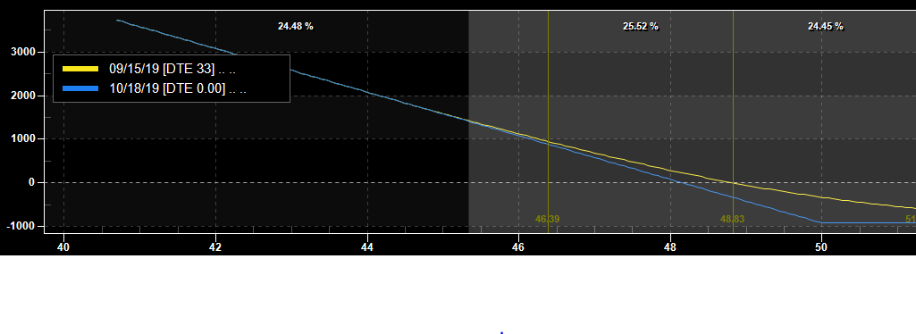

OK, now you know the individual scenarios. What happens when you combine the two of them? When you are long both WFC at 48.92 and long the WFC 18Oct19 50 puts in WFC at 1.85 then it should not affect your upside at all, should it?

Well, it does. It does not, however, affect it radically. Remember, puts are not free. You did have to pay 1.85 in premium to establish a long position in those puts. That amounts to $925 in insurance costs.

What happens below 50.00? Since the 18Oct19 50 puts give you the right to be short WFC at 50.00 then your downside loss will be limited. For every loss in the long stock below 50.00 there will be a concurrent gain in the long, put contract. The long 50 put acts as a circuit breaker for any further losses below 50.00. You would have a profit of $24,075.00 in the puts. The worst, case scenario is now a loss of $77 per trade. The $385 loss is a little more palatable than $24,460, wouldn’t you say? Have you noticed something? The long puts have a time value of 0.77. The strike price of 50, minus the 48.92 stock purchase price (1.08), subtracted from the 1.85 premium defines the maximum possible loss in the trade to the downside. Upside profit is unlimited.

GRAPH7

Long 500 shares WFC + Long WFC Oct 55 Put 5x

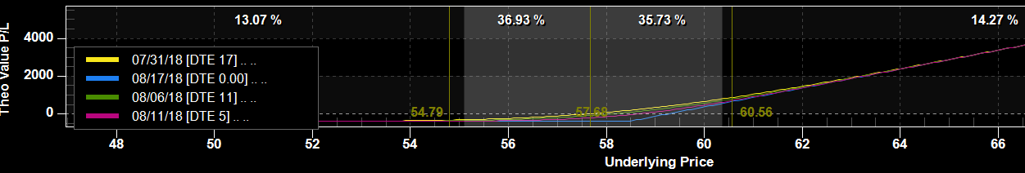

This is called a *protective put* because your *long stock* position is *protected* by the *long puts* that represent an equal number of potential shares. This also *acts identically* to being *long* an *outright WFC 18Oct19 50 call*. A *protective put* is a *synthetic long call*.

GRAPH8

Long 5 WFC 18Oct19 50 calls

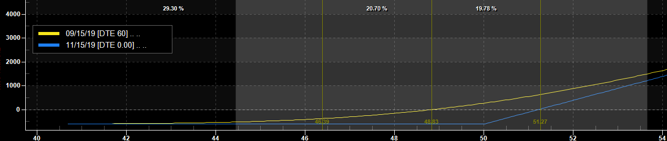

Look at another strategy. It is called the *covered call* or *buy-write* strategy. It involves shorting or *writing calls against* a *long stock* position. This is a *bullish* strategy. Go long 500 shares of DE at 82.40 and short 5 Sep82.50 calls in DE for 2.20. If, at Sep expiration, DE is trading at 82.50, your profit in the stock would be $50 while your profit in the calls would be $1,100. To the downside, losses begin at 80.20 due to the 2.20 that you picked up from the sale of the calls. The largest profit that you can make on this strategy is $1,150. When DE trades above 82.50 the short calls will cancel out any gain in the long stock. The most that you can lose is $40,100. Have you noticed something? The *short calls* have a *time value* of *2.20.* That *time value, plus the differential between the purchase price and the strike price* defines the *maximum possible profit* in the trade. The *covered call* acts the *same* way as *short put*. When you are *long stock* and *short* a *call* against it you are *synthetically short* a *put*.

GRAPH9

Long 500 shares DE Stock

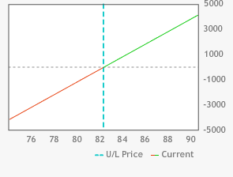

Graph10

Short DE Sep82.50 calls 5x

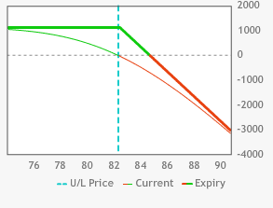

Graph11

Long 500 shares DE stock + short DE Sep 82.50 calls 5x

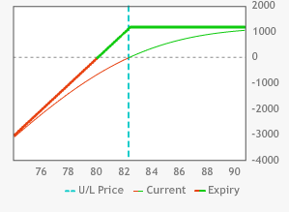

Graph12

Short DE Sep82.50puts 5x

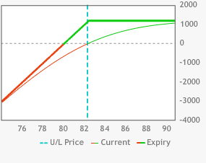

Our next strategy involves selling puts in combination with shorting stock. You start out by shorting 500 shares of JNJ at 96.25 while also selling five JNJ 19Sep 95 puts at 1.45. That upside breakeven point is 97.70. The short puts cancel out the profitability of the short stock position below 95.00. The profitability in the short stock is canceled out by the loss in the short puts below 95. The *position* is *identical* (disregarding interest & dividends) to a position of being *short* an *outright* Sep 95 call at 2.70 in JNJ. This is a strictly bearish position that also benefits from premium decay.

GRAPH13

Short 500 shares JNJ

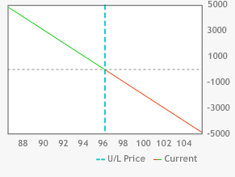

GRAPH14

JNJ Sep 95 short puts 5x

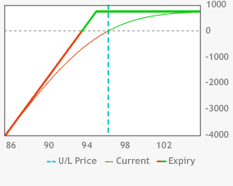

GRAPH15

JNJ short 500 shares + short Sep 95 puts 5x

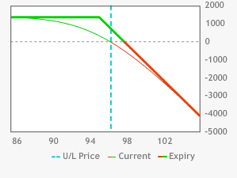

GRAPH16

Short JNJSep95 calls 5x

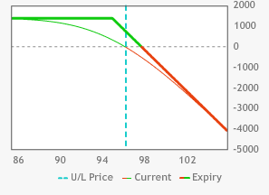

Here is yet another strategy. You are short 500 shares of MSFT at 106.12. Your upside risk on the short stock is unlimited. You do have, however, a substantial upside to the trade. $53,060 worth of upside to be exact, should MSFT plummet down to zero. Your next step is going long the MSFT Aug 106 calls five times for 1.93. This means that above 106, the long Aug calls will counteract the losses in the short stock. This position is *equivalent* to being *long* the MSFT Aug 106 *puts for 1.81 (excluding dividends and interest)*. When you *buy* a *call* against an *existing short stock* position you have *converted* your *short stock* position into a long *synthetic put.* Another way to look at it is that you have *converted* a *long call* into a synthetic *long put when the stock is shorted.*

GRAPH17

MSFT short 500 shares at 106.12

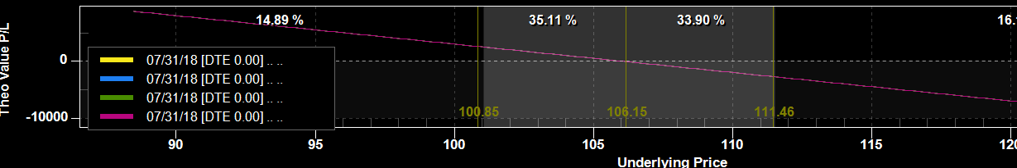

GRAPH18

MSFT long Aug106 calls 5x at 1.13

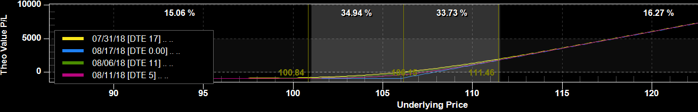

GRAPH19

Long 5 MSFT Aug 106 calls at 1.13 + MSFT short 500 shares at 106.12

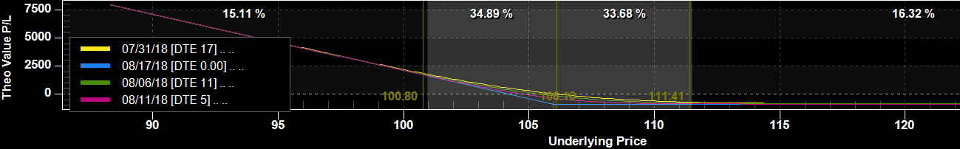

GRAPH20

Long MSFT Aug 106 puts at 1.98 5x

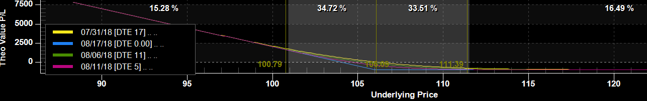

When you buy a call and sell a put in the same expiration cycle and at the same strike price then you have created a long stock (ETF or futures) position. When you buy 5 ORCL Jul 43 calls at 1.56 and sell 5 ORCL Jul 43 puts at 1.26 you have synthetically purchased 500 shares of ORCL at 43.30 (excluding dividends and interest). When ORCL settles above 43 at expiration you will exercise your five calls and wind up with a long position of 500 shares of ORCL. When ORCL settles below 43 at expiration you will be assigned on your five short puts and wind up with a long position of 500 shares of ORCL. You paid a 0.30 debit for the chance to take a long position in ORCL and so the synthetic basis for your trade is 43.30.

GRAPH21

Long 5 ORCL Jul 43 calls + short 5 ORCL Jul 43 puts

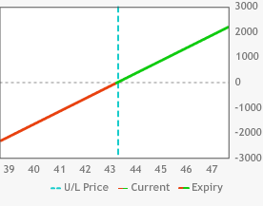

GRAPH22

Long 500 shares ORCL



When you buy a put and sell a call in the same expiration cycle and at the same strike price then you have created a short stock (ETF or futures) position. When you sell 10 CSCO Sep26 calls at 0.70 and buy 10 CSCO Sep 26 puts at 0.70 you have synthetically shorted 1,000 shares of CSCO at 26. When CSCO settles above 26 at expiration you will be assigned on your ten short calls and wind up with a short position of 1,000 shares of CSCO. When CSCO settles below 26 at expiration you will exercise your ten long puts and wind up with a short position of 1,000 shares of CSCO.

GRAPH23

Short 10 CSCO Sep 26 calls

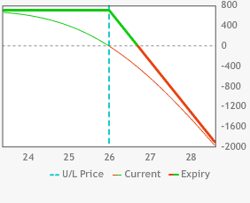

GRAPH24

Long 10 CSCO Sep 26 puts

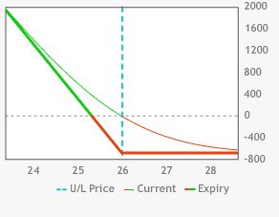

GRAPH25

Short 10 CSCO Sep 26 calls + Long 10 CSCO Sep 26 puts

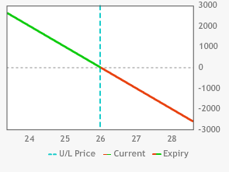

GRAPH26

Short 1000 shares CSCO

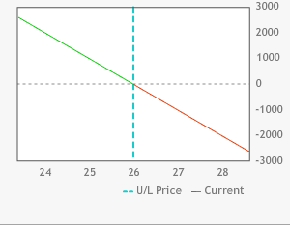

Time to recap synthetic options. Understanding them and how they work and then after you understand them then burn them into your brain. *Long call plus short stock* is *equivalent* to *long put*. *Short call plus long stock* is *equivalent* to *short put*. *Short put plus short stock* is *equivalent* to *short call*. *Long put plus long stock* is *equivalent* to *long call*. Long call plus short put in the same expiration cycle and the same strike price is equivalent to long stock. Long put plus short call in the same expiration cycle and the same strike price is equivalent to short stock.

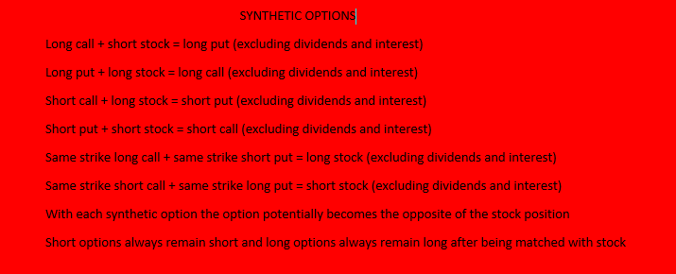

**OPTIONS BASICS QUIZ**

1. The first recorded history of options trading was employed by
2. Ramses regarding papyrus
3. Thales regarding olive presses
4. CBOE market-makers in 1973
5. Christopher Columbus regarding ships
6. Options trading was introduced to the USA by
7. Ford Dealer Burt Weinman in 1964
8. NY financier Russell Sage in 1872
9. Veg-O-Matic founder Ron Popeil in1967
10. J.P. Morgan in 1911
11. Edward O. Thorp’s book about__________was the first attempt at theoretical options pricing.
12. blackjack
13. craps
14. warrants
15. subpoenas
16. What was the first modern theoretical pricing model on options?
17. Mason-Dixon
18. Winn-Dixie
19. Sears-Roebuck
20. Black-Scholes
21. Which exchange first started trading publicly listed options?
22. CBOE
23. Amex
24. P-Coast
25. Philly
26. The greatest advantage in going long options is _____________.
27. defined risk
28. leverage
29. guaranteed profit
30. both a & b
31. A __________ option gives you the right but not the obligation to go long 100 shares of stock at a specific price within a specified time frame.
32. put
33. call
34. reversible
35. flexible
36. A __________ option gives you the right but not the obligation to go short 100 shares of stock at a specific price within a specified time frame.
37. put
38. call
39. reversible
40. flexible
41. Options sellers have _____________ but not ________________.
42. instructions, orders
43. rights, obligations
44. orders, instructions
45. obligations, rights
46. That certain level in options is the
47. bargain price
48. special price
49. sale price
50. strike price
51. That specific time frame in options is the
52. business cycle
53. expiration cycle
54. rinse cycle
55. tricycle
56. FB Aug 75 calls are __________when FB is trading at 75.
57. in-the-money (ITM)
58. out-of-the-money (OTM)
59. at-the-money (ATM)
60. near-the-money (NTM)
61. IBM Sep 180 puts are ______________ when IBM is trading @190.
62. ITM
63. OTM
64. ATM
65. NTM
66. BIDU Sep 220 puts are ______________ when BIDU is trading @218.
67. ITM
68. OTM
69. ATM
70. NTM
71. When you are long an ITM option at expiration you hand in an ____________ notice.
72. eviction
73. exercise
74. assignment
75. yoga
76. When you are short an ITM option at expiration you will receive an ____________ notice.
77. eviction
78. exercise
79. assignment
80. yoga
81. The price an option is traded at is called the _________________.
82. mark
83. coupon
84. premium
85. money notice
86. Premium is divided into ____________ value and _______________ value.
87. expiration, recovery
88. time, perceived
89. false, true
90. expiration, time
91. A covered call is equivalent to a ___________________.
92. long put
93. short put
94. long call
95. short call
96. A protective put is equivalent to a ___________________________.
97. long put
98. short put
99. long call
100. short call
101. When you short stock and short a put it is equivalent to a ________________.
102. long put
103. short put
104. long call
105. short call
106. When you are short stock and long a call it is equivalent to a ___________________.
107. long put
108. short put
109. long call
110. short call
111. When CAT Sep 105 calls have a premium of 2.30 with CAT trading @105.40 the time value is _________________.
112. 0.30
113. 2.30
114. 1.90
115. zero
116. When DE Sep 87.50 puts have a premium of 3.60 with CAT trading @84.55 the expiration value is _________________.
117. 3.60
118. zero
119. 2.95
120. 0.65
121. When SNDK Oct 90 puts have a premium of 3.20 with SNDK trading at 93.40 the time value is _________________.
122. 3.20
123. 6.60
124. zero
125. 3.40

**OPTIONS BASICS ANSWER KEY**

1)b Thales of Miletus in 322 BC bought calls on olive presses anticipating a bumper crop in olives.

2) b

Russell Sage introduced options to the USA. They were traded OTC.

3) c

Warrants were issued as sweeteners for along with a company’s bond offering. They allowed you to purchase the stock within a specific period of time at a certain price level. Sound familiar?

4) d

Fisher Black and Myron Sholes developed the model that Robert Merton’s paper explained in 1973. The CBOE was founded shortly thereafter.

5) a

See above.

6) d

When you go long an option your only loss is the premium paid. You can control many more shares of stock with options than with stock.

7) b

Call options give you the right to go long the stock.

8) a

Put options give you the right to go short the stock.

9) d

Option sellers have no choices when it comes to exercises and assignments.

10) d

Strike price is where long calls and short puts that are ITM at expiration go long the stock. Strike price is where short calls and long puts that are ITM at expiration go short the stock.

11) b

This is the time where options either die out or morph into long or short stock.

12) c

When the option is trading at or near where the stock is trading.

13) b

Options that have no expiration value are OTM.

14) a

When the stock closes there at expiration the 220 puts would be worth 2.00.

15) b

You have the right but not the obligation to initiate the transaction where you will be either long stock (call) or short stock (put) at a price better than you could get on the open market.

16) c

This is a passive short option position that obligates you to fulfill a contract. You will be either short stock (call) or long stock (put) at a price worse than you could get on the open market.

17) c

Premium is the price that the long and short agree upon to complete the transaction.

18) d

Expiration value is the value of the premium at expiration. Time value is the remainder of the premium.

19) b

When you are long stock and short a call you continue to lose money on the downside all the way to zero. To the upside you maximize your profits at the strike price and above, the same as short puts.

20) c

A protective put continues to make money on the long stock portion to infinity. The put defines the risk to the downside.

21) d

When you are short put and short stock you lose an unlimited amount to the upside due to the short stock. To the downside you capture the premium from the short put as the short stock insures against downside losses.

22) a

A short stock and long call position increasingly profits on the downside below the strike price to zero. Your short stock on the upside is protected by your long call so that you only lose the time value in the premium.

23) c

The Sep 105 calls would have a value at expiration of 0.40 with CAT trading at 105.40. The remaining 1.90 of premium is time value.

24) c

The Sep 87.50 puts would have a value at expiration of 2.95 with DE trading at 84.55. The remaining 0.65 of premium is time value.

25) a

The OCT 90 puts would have no value at expiration with SNDK trading @93.40. The entirety of the 3.20 premium is comprised of time value.

**INTERMEDIATE SECTION**

**Vertical Spreads**

In the basics section we touched on the result of combining stock and options in the same position. In this section, we will discuss combining long and short options positions together in one new position. These positions are called *spreads.*

In trading, the word spread has two meanings: One is the gap between the bid and the ask prices in any security or futures contract. The second is a position taken in two or more instruments to profit through a change in the relative price relationships.

Start with vertical spreads. What is a *vertical spread*? It is an options position where a trader makes a *simultaneous purchase and sale* of *two options* of the *same type* (call or put) that has the *same expiration date* but at *different strike prices*.

When you go long 10 DE Jun 93.50 calls for a premium of 1.69 then your account is debited $1,690 for that privilege. When DE settles at 95.50 at the Jun expiration the profit for your DE Jun 93.50 calls would be 0.31 ($310). The breakeven point for the long calls is 95.19 (strike + premium).

Obviously since the price of DE can go to infinity the potential upside profit is unlimited. The maximum loss for any long options position is always limited to the premium that is debited to your account. That would be $1,690 in this case.

GRAPH27

Long DE Jun 93.50 calls

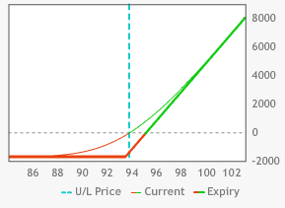

When you short 10 DE Jun 95.50 calls for 0.72 and DE closes at 95.50 at expiration your Jun 95.50 calls are now worthless. You have captured the maximum possible profit of $0.72 on your short calls for a profit of $720.Your upside breakeven point is 96.22. Standing alone, the risk in shorting the Jun95.50 calls is infinite, and your margin reflects that.

GRAPH28

Short DE Jun 95.50 calls

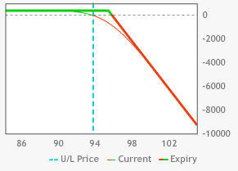

OK, now what happens when you go combine your *long Jun93.50 calls* with your *short Jun95.50 calls*? That is the essence a *vertical spread* (a *bull vertical call spread* to be exact). When you go long the DE Jun 93.50 calls for 1.69 and short the DE Jun 95.50 calls for 0.72 at the same time, then you have accrued a debit of 0.97(1.69-0.72) for what is called the DE Dec 93.50-95.50 long vertical call spread.

GRAPH29

Long DE Jun 93.50-95.50 call spread

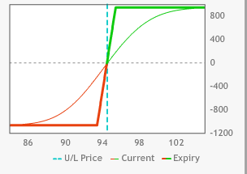

What is the *maximum value* for this spread? The DE Jun 93.50 calls are a long position so their profit can run forever. The DE Jun 95.50 calls are a short, however, so any move above 95.50 means that the 95.50 losses could also run forever. The *profit* on the *Jun 93.50 calls*, therefore, can only *run as far as 95.50*. The possible loss of the short 95.50 calls is eliminated by the long 93.50 calls that will gain in value step by step with the loss in the short 95.50 calls. So now I think that you can draw a conclusion to the question. The *maximum value* for your spread is *2.00*. This occurs at *95.50 or higher*. The *minimum value* of *zero* for the spread occurs when both calls go out worthless. That occurs at *93.50 or lower*. What would the *maximum possible profit* for this spread be? That would be the *max value less the debit* that was incurred in initiating the spread. That would be *1.03* in this case (2.00 – 0.97). The *maximum possible loss* for this spread would be the *debit of 0.97* that was accrued while creating the spread. It occurs at the minimum value (93.50 or lower).

Why would a trader establish a position with such limited returns, albeit with a smaller maximum loss? The fact is that home runs do not occur nearly as often as singles do. When DE closes at 95.30. Going long the naked 93.50 call would result in a profit of 0.11 while the profit for the spread,0.83, would be greater than seven times that of the naked long call. Your breakeven point has been reduced by 0.72. Gap moves are not that frequent, so reducing your downside risk and lowering your breakeven point makes sense even though you sacrifice the possibility of a huge profit.

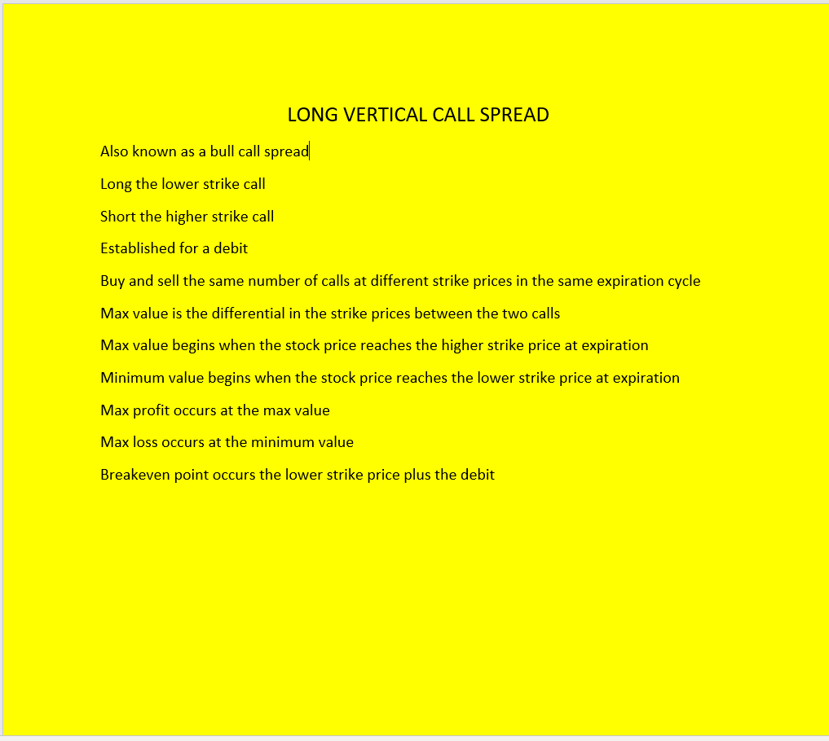

You now know that the DE Jun93.50-95.50 call spread is a vertical bull call spread. What would a vertical *bear* call spread look like? Well, since you went long the lower 93.50 strike and shorted the higher 95.50 strike for a bull spread, it makes sense that going long the higher strike call and shorting the lower strike call would result in a bear spread. Use the CAT Sep79-76 spread as an example. Reversing the order of strike prices from a bull spread, you are going long the less expensive, higher strike call and shorting the more expensive, lower strike one. It follows logically that a decline in the price of CAT would be beneficial since the more expensive call would have more to lose than the less expensive call. In the bull spread, the max value starts at 95.50 and the minimum value starts out at 93.50 and lower where both calls would be worthless. In the *bear call spread* the *value maxes* out at *79 and above* and the *minimum value* occurs at *76 and below.* When the *bear spread* is shorted at 1.18, the *max profit* is *1.18 at the minimum value of 76 and below,* while the *max loss* is*1.82 at the spread’s max value of 79 and above.* Another way to look at a vertical bear call spread is to look at naked shorting the CAT Sep76 calls at 2.00. The upside breakeven point is78.00. Losses go on forever to the upside. The max profit of 2.00 occurs at 76 or lower. A long call position in the CAT Sep79 calls would have an infinite upside. Going long the CAT Sep 79 calls at 0.82 would stop the bleeding from 79 and above in the spread. It would reduce the max profit by 0.82, but you would sleep much better and your margin department would be much more hospitable.

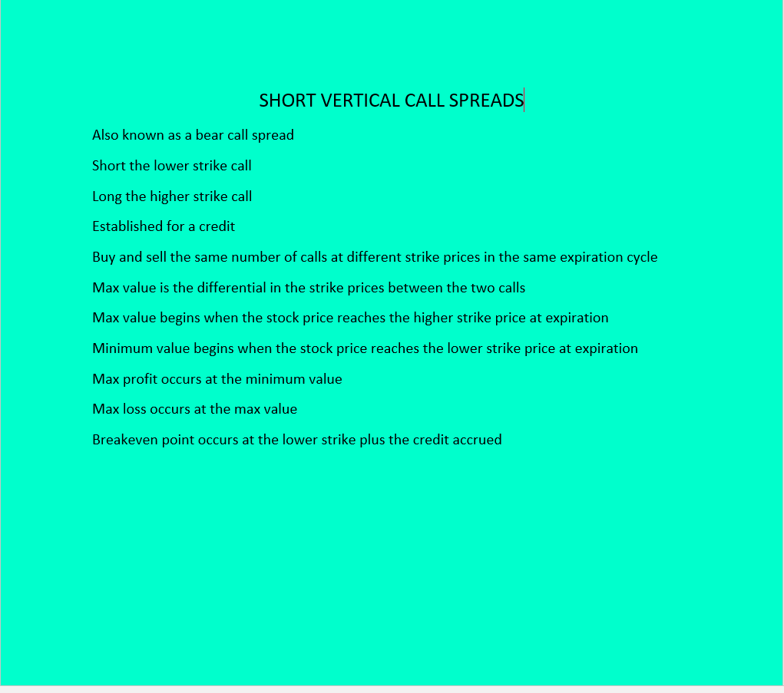

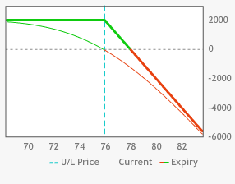

GRAPH30

Short CAT Sep 76 calls

GRAPH31

Long CAT Sep 79 calls

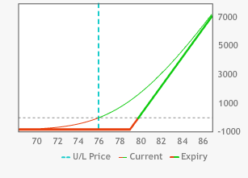

GRAPH32

Short CAT Sep 79-76 call spread

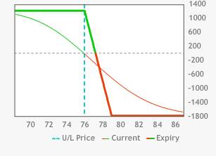

How do things work with vertical put spreads? Remember that puts are the mirror image of calls. Since the DE Jun 93.50-95.50 *vertical call spread increases* in *value* as DE *rises* in *price*, it is a *bull spread*. The DE Jun 93.50-95.50 vertical *put* spread *decreases* in *value* as DE *rises* in *price* and since you want the DE Jun 93.50-95.50 vertical put spread to go to the higher strike price just like our call spread, it is, therefore, also a bull spread.

When you go long the DE Jun 93.50 puts for 1.53 and short the DE Jun 95.50 puts for 2.60 you receive a credit of 1.07 for the spread. At any price *95.50 or above* the DE Jun 93.50-95.50 put spread hits its *minimum value of zero*, with both the DE Jun 93.50 puts and the DE Dec 95.50 puts expiring worthless. If DE closes at expiration at *93.50 or below*, the vertical put spread goes to its *max value of 2.00*. The short, DE Jun 95.50 put increasingly picks up value as DE declines. It will pick up value all the way to zero. The increasing price of the DE Jun 95.50 puts are hedged, however, by the DE Jun 93.50 puts. *Bullish* put verticals occur when a *short position* is established in the *higher strike price puts* and a *long position* is established in the protective, *lower strike puts*. This is done for a *credit*. Another way to look at it is to look at shorting a naked DE Dec 95.50 put at 2.60. The downside breakeven point is 92.90. That means that the max loss is 92.90. The max profit occurs at 95.50 or above. Going long the DE Jun 93.50 Puts at 1.53 acts as a circuit breaker for any further losses below 93.50. It substantially reduces your max profits, but it defines your max loss and once again keeps that pesky margin department at bay.

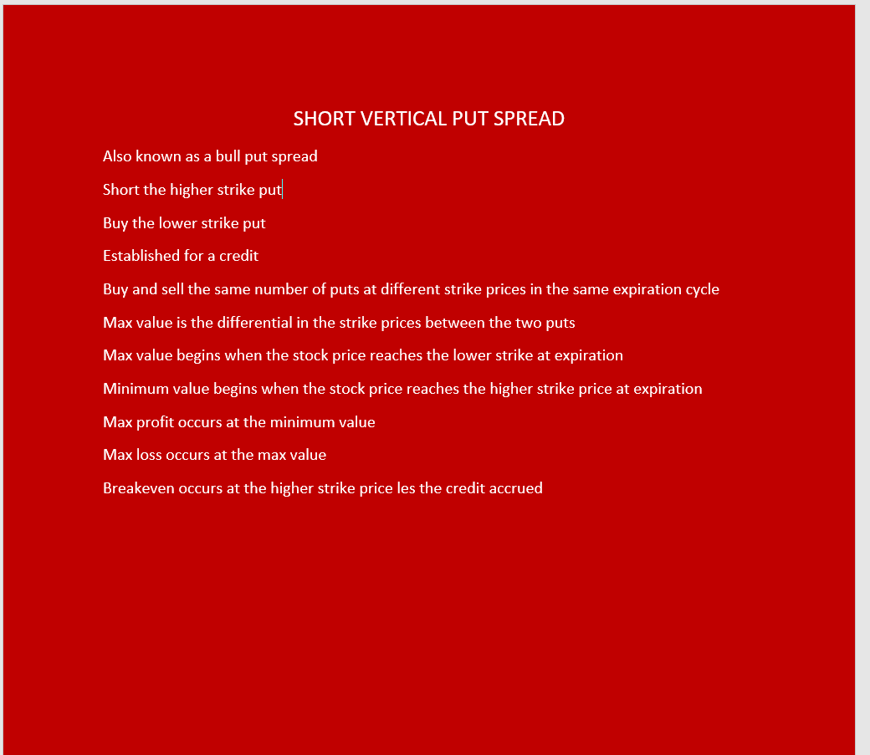

GRAPH33

Short 10 DE Jun 95.50 puts

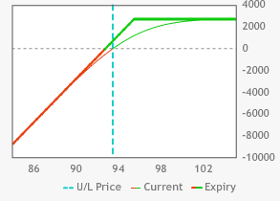

GRAPH34

Long 10 DE Jun 93.50 puts

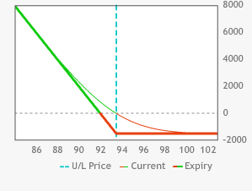

GRAPH35

Short DE Jun 93.50-95.50 put spread

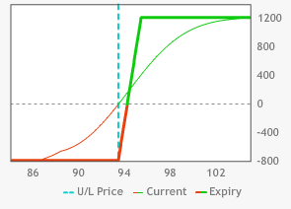

*Bearish put verticals* require a *long* position in the *higher strike price puts* and a *short* position in the *lower strike price puts*. This is done for a *debit*. *Shorting* the *lower strike* put *reduces* the *max profit* but it also *reduces* the *max loss and lowers the breakeven point*. Once again singles are much more common than home runs. When you go long the CAT Jul 90 puts at 5.20 the downside breakeven point occurs at 84.80. It is pure gravy after the breakeven point with the max profit of 84.80 occurring at zero. When CAT settles at 87.50 at expiration that would result in a loss of 2.70 for the naked, long put. What happens then when you short the Jul 87.50 puts at 3.40? The *profit* on the *Jul 90.00 puts*, therefore, can only *run as far as 87.50*. The possible *loss* of the *short 87.50 puts* is *eliminated by* the *long 90.00 puts* that will gain in value step by step with the loss in the short 87.50 puts. You have now created a bear put vertical with a maximum value of 2.50. The *max value* occurs at *87.50 or lower*. The *minimum value* of *zero* for the spread occurs when *both puts go out worthless*. That *occurs* at *90.00 or higher*. What is *maximum profit* for this spread? That is the *max value less the debit* that was incurred in initiating the spread. That is *0.70* in this case (2.50 – 1.80). The *maximum possible loss* for this spread is the *debit of 1.80 (at 90.00 and above)* that is accrued in creating the spread.

Why would a trader establish a position with such limited returns, albeit with a smaller maximum loss? The fact is that home runs do not occur nearly as often as singles do. When CAT closes at 85.60 going long the naked 90.00 put would result in a loss of 0.80 while the profit for the spread, 0.70.

GRAPH35

Long CAT Jul 90 puts

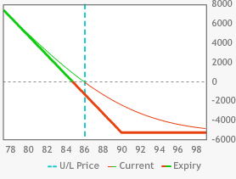

GRAPH36

Short Jul 87.50 puts

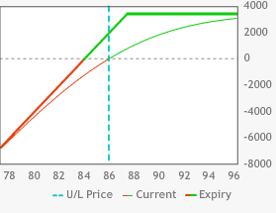

GRAPH37

Long CAT 90-87.50 put spread

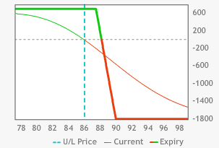

Have you noticed anything? When you *short* the DE Jun *93.50-95.50 put spread* at *1.07* its *max profit is 0.04 superior to* the long DE Jun*93.50-95.50 call spread* at *0.97*. Its max loss of 0.93 is 0.4 superior to the max loss of the call spread. Likewise, when you go *short* the CAT*90-87.50 call spread* for *0.77* it is *seven cents superior* to going *long* the DE Jul*90-87.50 put spread* for *1.80*. Many beginning options traders believe that establishing a credit on a spread is advantageous to establishing a debit spread. When you establish a credit spread you never add any funds to your account until the spread is marked below where you established your credit. Any move above that credit results in losses to your account. The wisest move is to compare the debit and credit spreads and then choose whichever one is better priced.

Please review certain points about vertical call and put spreads. For vertical call spreads when you go long the lower (and more expensive) strike and short the higher (and less expensive) strike for a debit then you are going long a vertical bull call spread. When you go long the higher (and less expensive) strike and sell the lower (and more expensive) strike for a credit you are shorting a vertical bear call spread.

For vertical put spreads when you go long the higher (and more expensive) strike and short the lower (and less expensive) strike for a debit you are going long the vertical bear put spread. When you go long the lower (and less expensive) strike and sell the higher (and more expensive) strike for a credit you are shorting the vertical bull put spread.

These are the basic vertical spreads. Next up is exploring vertical spreads in a slightly more complex manner.

**Straddles & Strangles**

Now look at an options strategy that deals with puts and calls in the same trade. This strategy is called a *straddle.*

When somebody straddles the fence, they are not sure which side of the fence that they want to land on. Is a long straddle a good position to establish for somebody who cannot decide which direction the stock is headed? If they recognized value, then it would be. The value aspect will be covered later. You need to first learn the mechanics of a straddle.

When you establish a *long straddle* position you are simultaneously going *long* an *equal number* of *calls and puts* at the *same strike price* and the *same expiration cycle* in the *same stock*. Look at the Jul options in M, with M trading at 59. When you go long ten M Jul 59 calls for 1.70 then you have established a debit of $1,700 in your account in exchange for an unlimited, upside ride on the coattails of M. You can make millions and your loss is limited to the premium that was debited for your calls. Your position would become profitable when M surpassed 60.70 in price. Going long straight calls can only be profitable with an upward movement in M.

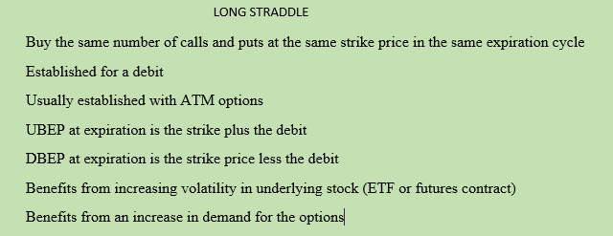

GRAPH38

Long M Sep 59 calls 10x

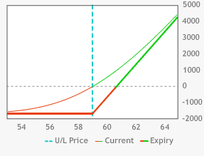

When you go long ten M Sep 59 puts for 1.95 then you are debited $1,950.00 for the possibility of seeing M plummet down to zero. Since you would have a short position in M at 59 your downside breakeven point would be 57.05. If M were to go all the way to zero your profit on the ten puts would be $57,050. A straight long position in the puts can only be profitable with a downward movement in M.

GRAPH39

Long M Sep 59 puts 10x

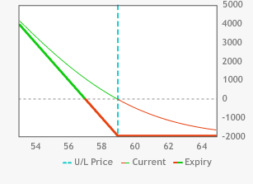

What happens when you establish a long position in the M Sep 59 straddle ten times? You then stand to profit whether M goes up or down; and stand to lose when M sits still. You would be debited 3.65 for the straddle. That would be a total of $3,650.00 for the opportunity to profit with an up or down move in M. You would now become profitable at expiration when M surpasses 62.65, an upside breakeven point 1.95 higher.

You become profitable when M trades below 55.35. Your new downside breakeven point is 1.70 lower; again because of the higher premium for the straddle rather than for the put alone. Having it both ways, in the market at least, is more expensive than merely buying either the puts or the calls, but it does give you more options (pun intended).

GRAPH40

Long M Sep 59 straddle 10x

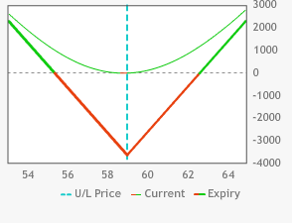

When you carry this position until expiration then either the call or the put will be exercised, and you will be either long or short M stock. That is, unless M closes exactly at 59. It appears that 59 would be the dead zone for your long straddle. When you are going long the M Sep59 straddle, you would be hoping that M would break out of the range between55.35 and 62.65. This would be a strategy that you might use when you expected a high degree of volatility in the underlying stock. Does this automatically mean that this trade would be a loser if the stock never trades above or below those levels? No, but you will learn about that later.

What happens when you are short a straddle? Look at the WMT Dec 72.50 short straddle. You can sell the Dec 72.50 calls at 3.00 and the Dec 72.50 puts at 3.25. OK, you know that when you are short the WMT Dec72.50 calls that the calls can run up to infinity plus one. When you are short the WMT72.50 puts you know that the put premium skyrockets to 72.50 when WMT travels down to zero. Obviously when you go short the straddle you are hoping for a small degree of movement either way in the underlying stock. Your sweet spot would be 72.50 since any price above 72.50 would go against your short 72.50 calls and any price below 72.50 would go against your short 72.50 puts. You would be profitable at expiration at any price between 66.25 and 78.75. Does this automatically mean that this trade would be a loser if the stock closes above or below those levels at expiration? No, but no need to cover that yet.

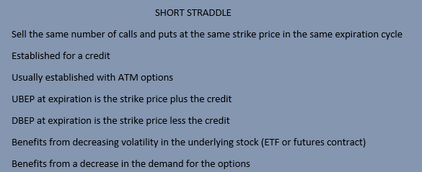

GRAPH41

Short WMT72.50 calls 10x

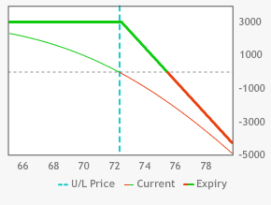

GRAPH42

Short WMTDec 72.50 puts 10x

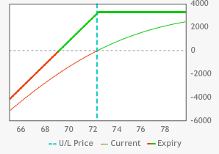

GRAPH43

Short WMT72.50 straddle 10x

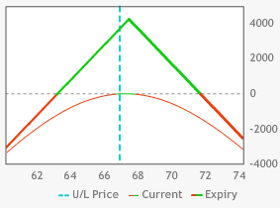

A strategy that involves the *simultaneous purchase* of an *OTM put* and an *OTM call* (equidistant in price from the underlying stock) in the *same expiration cycle* is referred to as the *long strangle*. A long strangle position makes money when the stock price moves up or down, well past the current stock price. Use the same example of WMT trading at 72.38. An example of a long WMT strangle involves going long the Dec 82.50 calls at 0.49 and going long the Dec 62.50 puts at 0.57. You have established the long strangle for 1.06. Your UBEP would be 83.56. Your DBEP would be 61.44. To make a profit in the long strangle, you need WMT to move to an even greater extent than is needed with the long straddle. There is not as much premium risk in the long strangle as there is in the long straddle. The long strangle is a less expensive long volatility strategy than the long straddle for traders expecting a breakout in either direction in the underlying stock.

GRAPH44

Long WMT Dec 82.50 calls 10x

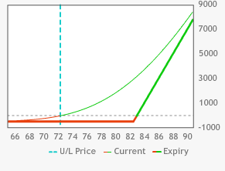

GRAPH45

Long WMTDec 62.50 puts 10x

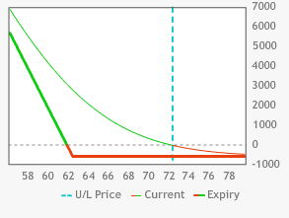

GRAPH46

Long WMTDec 62.50 put-72.50 call strangle

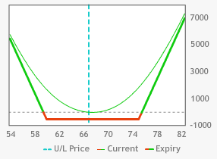

Conversely, when you establish the WMT Dec 62.50-72.50 short strangle for 0.96 the position would be ITM between 61.54 and 73.46. Shorting volatility in WMT is less likely to go ITM with a short strangle than with a short straddle. On the other hand, you would not be establishing as much of a short premium position (and potential profit) as a result.

GRAPH47

Short WMT Dec 62.50 puts

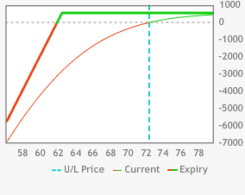

GRAPH48

Short WMT Dec 82.50 calls 10x

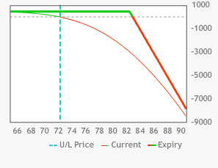

GRAPH48

Short WMT Dec 82.50-62.50 strangle 10x

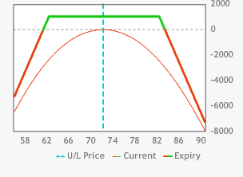

**Iron Butterfly**

You can also combine a short straddle with a long strangle. The short straddle has unlimited potential upside losses and massive potential downside losses. When you establish a long strangle against your short straddle you are defining your maximum possible losses to both the upside and the downside.

Look at matching up the WMT Dec72.50 short straddle with the WMT Dec 62.50-82.50 long strangle. You have created a short WMT Dec 62.50-72.50 put spread in conjunction with a short WMT Jul 82.50-72.50 call spread. If one of the spreads is ITM then the other one, by definition, is OTM. When you combine the debit of 1.06 from the long strangle with the 6.25 credit from the short straddle you arrive at a credit of 5.19. Each vertical spread could potentially be worth up to 10.00. That means that the maximum possible loss for this position would be 4.81 for each time the position is established. This would happen anywhere 62.50 or below or 82.50 and above. The UBEP would be 77.69 and the DBEP would be 67.31. You have lessened your maximum possible profit by $106 per trade but you have also limited your losses to just a little over $481 per trade. This is called the iron butterfly.

GRAPH49

Short WMT Dec72.50 straddle 10x

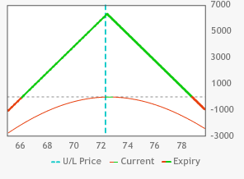

GRAPH50

Long WMT Dec 62.50-82.50 strangle 10x

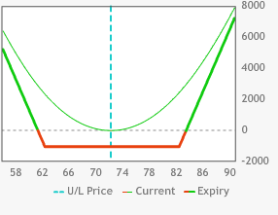

GRAPH51

Long M 60-67.50-75 Iron Butterfly 10x

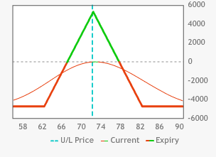

**Iron Condor**

An iron butterfly consists of shorting an ATM vertical put spread in conjunction with an ATM vertical call spread. Now look at shorting an OTM vertical put spread in conjunction with shorting an OTM vertical call spread. Once again, if one of the spreads finishes ITM at expiration then the other spread, by definition, finishes OTM at expiration. This is called the Iron Condor. It is really a covered short strangle.

Look at the example of the short BIDU Jan 100-105 put spread at 0.45 and the short BIDU Jan 200-195 call spread at 0.50. You have established a credit of 0.95. The max value for each vertical spread is 5.00. The maximum possible loss is 4.05. The good thing is that 105 through 195 you max out your profits. These spreads have a very, high probability of success but all it takes is one big move in the market and several months of profits can be wiped out.

GRAPH52

Short BIDU Jan 100-105 put spread 10x

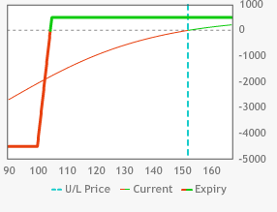

GRAPH53

Short BIDU 200-195 call spread 10x

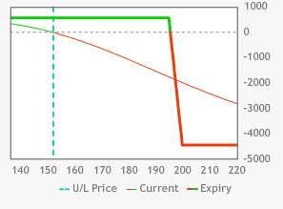

GRAPH54

BIDU Iron Condor 10x

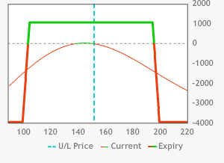

**Boxes**

Look at going long a vertical call spread while you simultaneously go long a put vertical spread with the same strike prices. This trade is called a long box.

When you go long 5 QQQ 11Oct19 190 calls at 3.35 and get short 5 QQQ 11Oct19 193 calls at 1.67 you have gone long the QQQ 11Oct19 190-193 call vertical for 1.68. The net debit of 1.68 ($840) is the max loss for that vertical at 190 or lower. The max profit for the spread is 1.32 ($660) at 193 and above.

GRAPH55

Long QQQ 11Oct19 190-193 long vertical call spread 5x

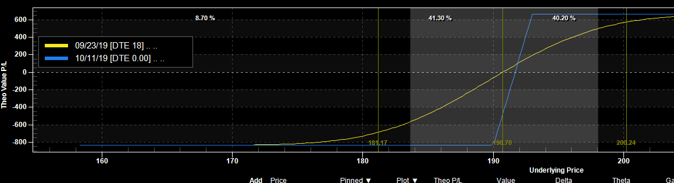

OK, what happens when you go long 5 QQQ 11Oct19 193 puts at 3.69 and short 5 QQQ 11Oct19 190 puts for 2.40? You have established a long position in the QQQ Sep 193-190 put vertical for 1.29. The maximum, possible loss for this spread is 1.29 ($645) at 193 and higher. The max profit for the spread is 1.71 ($855) at 190 or lower.

GRAPH 56

Long QQQ Sep 193-190 put vertical 5x

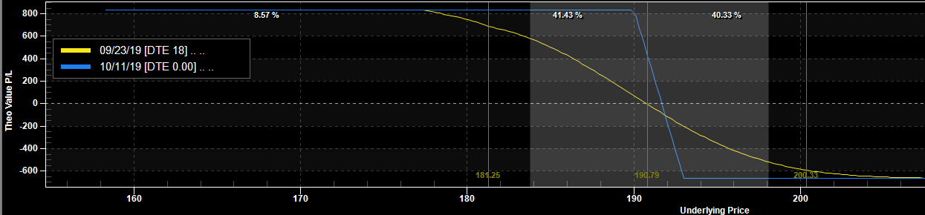

You are long the combined verticals for 2.97. The value for the box will always be 3.00 at expiration. When QQQ is 190 or lower the put vertical is at its max value of 3.00 and the call vertical is worthless. When QQQ is 193 or higher the call vertical is at its max value of 3.00 and the put vertical is worthless. When QQQ settles at 191.50, both verticals will be worth 1.50. When QQQ closes at 191 at expiration your call vertical is worth 1.00 and your put vertical is worth 2.00. When QQQ closes at 192 at expiration your call vertical is worth 2.00 and your put vertical is worth 1.00. You have locked in a 0.03 profit ($30) regardless of where QQQ closes at expiration.

The box will always close at 3.00 at expiration so any opportunity to acquire a long position below 3.00 should be jumped on aggressively. It might seem logical that going short the box above 3.00 would be an in your face, slam dunk. If the box lasts until expiration, then it will be jam city. That is not always the case. In fact, the box can trade much higher than 3.00, so shorting the box is unwise for that reason. That will be covered later.

**Butterflies**

What happens when you go long 10 BABA Sep 68 calls for 3.95 and then go short 10 BABA Sep70 calls for 2.65? You have gone long the BABA Sep68-70 vertical call spread for a 1.30 debit. Your maximum possible loss for the spread is the 1.30 ($1,300) debit at 68 and below. Your max possible profit is 0.70 ($700) at 70 and above.

GRAPH57

BABA Sep 68-70 long vertical call spread 10x

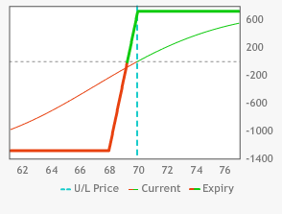

Then what happens when you go long the BABA Sep72 calls for 1.65 and short the BABA Sep70 calls for 2.65? You have then shorted the BABA vertical call spread for 1.00. The maximum possible profit for the spread is the 1.00 ($1,000) credit that expires worthless at 70 or lower. The max possible loss of 1.00 ($1,000) would occur at 72 or higher.

GRAPH58

BABA Sep 72-70 short vertical call spread 10x

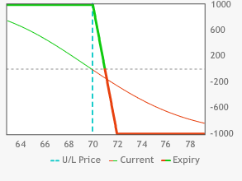

What happens when you combine the bull spread with the bear spread? The 1.30 debit for the bull vertical call spread (68-70) that is combined with the 1.00 credit for the bear vertical call spread (72-70) works out to be a debit of 0.30 for the entire spread. This is called a long call butterfly spread. Butterflies are not free, unlike the old Goldie Hawn movie. If you can buy one for free, then load up on it. You are buying the wings (68&72) and shorting the middle strike (70).

Whenever you go long the wings and short the middle strike you are going long the butterfly. Whenever you go long the middle strike and short the wings you are shorting the butterfly.

Look at how your BABA call butterfly fares in some different scenarios. If BABA settles at 68 at expiration, your BABA Sep 68-70 vertical call spread will then go out worthless for a loss of 1.30, while the BABA 72-70 vertical call spread will also go out worthless, resulting in a profit of 1.00. Your net loss on the long call butterfly spread would be the original debit of 0.30.

If BABA closes at 72 at expiration, your BABA 68-70 vertical call spread maxes out at 2.00, resulting in a profit of 0.70, while the BABA 72-70 vertical call spread also maxes out at 2.00 for a loss of 1.00. The net loss on your butterfly is again 0.30.

 

Split the difference and see what happens when BABA closes at 70 at expiration. Your BABA Sep 68-70 vertical call spread will then go to 2.00 for a max gain of 0.70, while your BABA Sep 72-70vertical call spread will go out worthless for a max gain of 1.00. Your net profit on the BABA Sep 68-70-72 call butterfly is 1.70. The middle strike of a long butterfly is obviously the sweet spot for maximum profitability. It is the price where the lower strike vertical is at its maximum profitability with the upper strike vertical still worthless. The DBEP is 68.30 and the UBEP is 71.70.

GRAPH59

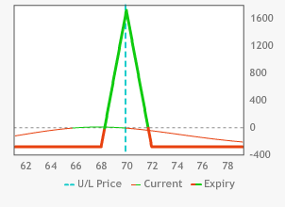

What happens when you go long BABA Sep 72 puts for 3.60 and then go short the BABA Sep70 puts for 2.63? You have then gone long the BABA vertical put spread for a 0.97 debit. Your maximum possible loss for the spread is the 0.97 debit ($970) at 72 and above. Your max profit is 1.03 ($1,030) at 70 and below. The breakeven point is 71.03.

GRAPH60

Long BABA Sep 72-70 put spread 10x

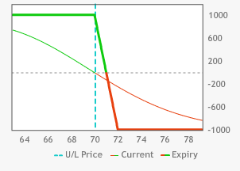

What happens when you go long the BABA Sep 68 puts for 1.92 and short the BABA Sep70 puts for 2.63? You have then shorted the BABA Sep 68-70 vertical put spread for 0.71. The maximum profit for the spread is the 0.71 ($710) credit that occurs at 70 or higher. The max loss of 1.29 ($1,290) would occur at 68 or lower. The breakeven point is 69.29.

GRAPH61

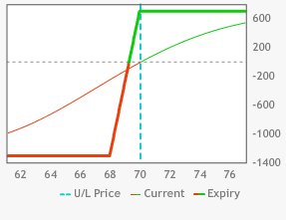

What happens when you combine the two spreads together? The 0.97 debit for the bear vertical, put spread (72-70) that is combined with the 0.71 credit for the bull vertical put spread (68-70) works out to be a debit of 0.26 for the entire spread. This is called a long, put butterfly spread. You are buying the wings (68 &72) and selling the middle (70).

Whenever you go long the wings and short the middle strike you are going long the butterfly. Whenever you go long the middle strike and short the wings you are shorting the butterfly.

Look at how your BABA Sep put butterfly fares in some different scenarios. If BABA closes at 68 at expiration, the BABA Sep 68-70vertical put spread will then go out at the max value of 2.00 for a loss of 1.29, while the BABA Sep 72-70 vertical put spread will also go to its max value for a profit of 1.03. Your net loss on the long, put butterfly spread would be the original debit of 0.26 ($260).

If BABA closes at 72 at expiration, the BABA Sep 72-70 put vertical spread goes out worthless for a loss of 0.97, while the BABA Sep 68-70 vertical put spread also goes out worthless for a gain of 0.71. Your net loss on your butterfly is again 0.26 ($260).

Split the difference and see what happens when BABA closes at 70. The BABA Sep 68-70 vertical put spread will then go out worthless for a max profit of 0.71 ($710), while the BABA 72-70 vertical put spread will go out at 2.00 for a max profit of 1.03 ($1,030). Your net profit on the BABA Sep 72-70-68 long put, butterfly is 1.74 ($1,740). The middle strike of a long butterfly is obviously the sweet spot for maximum profitability. It is the price where the lower strike put vertical goes out worthless while the upper strike put vertical is at its maximum profitability. The breakeven points are 68.26 and 71.74.

GRAPH62

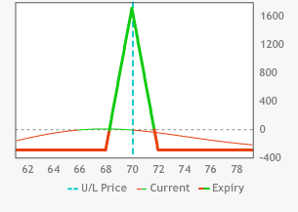

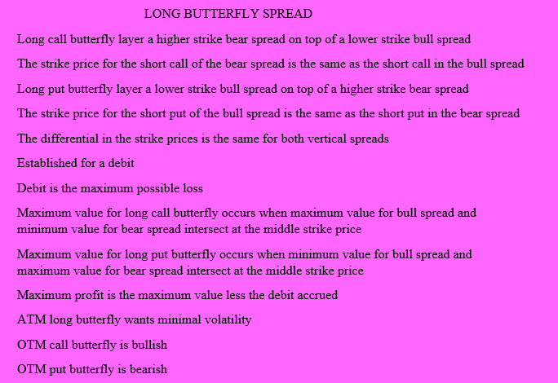

What happens when you go long SPY Sep199 calls for 4.50 and then go short the SPY Sep 202 calls for 2.80? You have then gone long the BABA Sep199-202 vertical call spread for a 1.70 debit. Your maximum profit for the spread is 1.30 ($1,300) at 202 and above. Your max loss is 1.70 ($1,700) at 199 and below. Your breakeven point is 200.70.

GRAPH63

Long SPY Sep 199-202 call spread

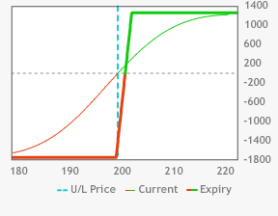

Then what happens when you go short the SPY Sep 196 calls for 6.60 and long the SPY Sep199 calls for 4.50? You have then gone short the SPY Sep202-199 vertical call spread for a credit of 2.10. The maximum loss for the short vertical spread is 0.90 ($900) at 202 or higher. The max profit of 2.66 ($900) would occur at 196 or lower.

GRAPH64

Short SPY Sep 199-196 call spread

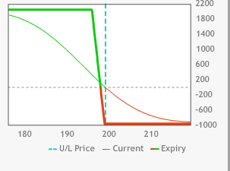

What happens when you combine the two spreads together? The 2.10 credit for the bear vertical call spread (199-196) that is combined with the 1.70 debit for the bull vertical call spread (199-202) works out to be a credit of 0.40 for the entire spread. This is called a short call butterfly spread. You are selling the wings (196&202) and buying the middle (199).

Whenever you go short the wings and go long the middle strike you are going short the butterfly.

Look at how the SPY short call butterfly fares in some different scenarios. If SPY settles at 196 at expiration, your SPY Sep199-196 vertical call spread will then go out worthless for a profit of 2.10, while your SPY Sep 199-202 vertical call spread will also go out worthless for a loss of 1.70. Your net profit on the short call butterfly spread would be the original credit of 0.40 ($400).

If SPY closes at 202 at expiration, the SPY Sep 199-202 vertical call spread maxes out at 3.00 for a gain of 1.30, while the SPY Sep 199-196 vertical call spread also maxes out at 3.00 for a loss of 0.90. Your net profit on your butterfly is again 0.40 ($400).

Split the difference and see what happens when SPY closes at 199 at expiration. The SPY Sep 199-202 vertical call spread will then go out worthless for a max loss of 1.70, while the SPY Sep 199-196 vertical call spread will go to its max value of 3.00 for a loss of 0.90. Your net loss on the SPY Sep196-199-202 call butterfly is 2.60. The middle strike of a short butterfly is obviously the death spiral for the spread, resulting in its maximum loss. It is the price where the lower strike short vertical is at its maximum value while the upper strike price long vertical goes out worthless for its maximum loss. The UBEP is 201.60 and the DBEP is196.40.

GRAPH65

SPY Sep 196-199-202 short call butterfly

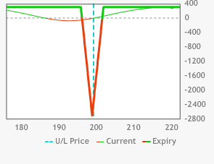

What happens when you go short QQQ Sep102.50 puts for 1.70 and then go long the QQQ Sep105.50 puts for 2.70? You have then gone long the QQQ Sep 105.50-102.50 vertical put spread for a 1.00 debit. Your maximum possible profit for the spread is the 2.00 ($2,000) at 102.50 and below. Your max loss is the 1.00 debit ($1,000) at 105.50 and above.

GRAPH66

Short QQQ Sep 105.50-102.50 put spread

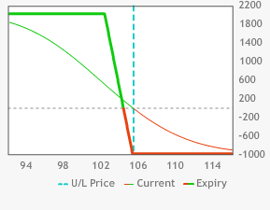

What happens when you go short the QQQ Sep 108.50 puts for 4.25 and long the QQQ Sep 105.50 puts for 2.70? You have then gone short the QQQ Sep 105.50-108.50 vertical put spread for 1.55. The maximum gain for the spread is 1.55 ($1,550) that occurs at 108.50 or higher. The max loss of 1.45 would occur at 105.50 or lower.

GRAPH67

Short QQQ Sep 105.50-108.50 put spread

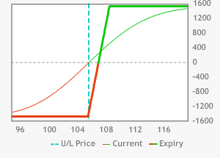

What happens when you combine the two spreads together? The 1.55 credit for the bull vertical put spread (105.50-108.50) that is combined with the 1.00 debit for the bear vertical put spread (105.50-102.50) works out to be a credit of 0.55 for the entire spread. This is called a short, put butterfly spread. You are selling the wings (102.50 &108.50) and buying the middle strike (105.50).

Whenever you go short the wings and long the middle strike you are going short the butterfly. Whenever you go short the middle strike and long the wings you are going long the butterfly.

See how the QQQ short Sep put butterfly fares in some different scenarios. If QQQ settles at 102.50 at expiration, the QQQSep105.50-102.50 vertical put spread will then go out at max value (3.00) for a profit of 2.00, while the QQQ Sep 105.50-108.50 vertical put spread will also go to its max value (3.00) for a loss of 1.45. The net profit on the short, put butterfly spread would be the original credit of 0.55 ($550).

If QQQ closes at 108.50 at expiration, the QQQ Sep105.50-102.50 put vertical spread goes out worthless for a loss of 1.00, while the QQQ Sep105.50-108.50 vertical put spread also goes out worthless for a profit of 1.55. The net profit on the butterfly is again 0.55 ($550).

Split the difference and see what happens when QQQ closes at 105.50 at expiration. The QQQ Sep105.50-102.50 vertical put spread will then go out worthless for a max loss of 1.00 ($1,000), while the QQQ Sep105.50-108.50 vertical put spread will go out at 3.00 for a max loss of 1.45 ($1,450). Your net *loss* on the QQQ Sep102.50-105.50-108.50 short put butterfly is 2.45 ($2,450). The middle strike of a short butterfly is obviously the death spiral for maximum losses. It is the price where the lower strike long put vertical goes out worthless while the upper strike short put vertical is at its maximum profitability. The UBEP is 107.95 and the DBEP is103.05.

GRAPH68

QQQ 102.50-105.50-108.50 short put butterfly

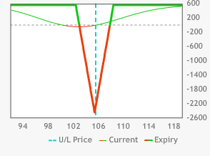

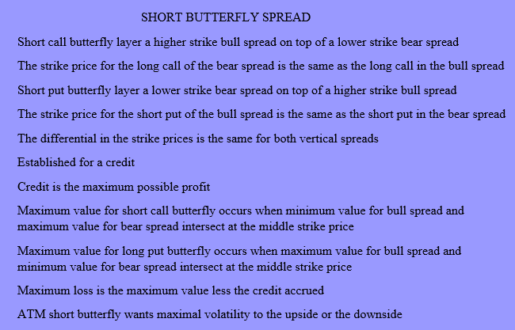

Another butterfly to look at is the uneven butterfly. Look at the AAPL 113-115-119 call butterfly. The AAPL Sep113 calls are offered at 3.80 and the Sep115 calls are bid at 2.71. See what happens when you get long the Sep 113-115 call vertical for 1.09 twenty times. The Sep117 calls are offered at 1.90. The Sep119 calls are offered at 1.21. You decide to sell the Sep119-115 call spread for 1.50. You only sell it ten times. You are shorting a four, dollar vertical spread, while you are going long a two, dollar vertical spread. Your maximum loss is 0.68 ($680) at 119 and above or 113 and below. Your maximum profit is 3.32 ($3,320) at 115 when your bull spread maxes out and your bear spread is still worthless.

GRAPH 69

AAPL Long Sep113-115 call spread

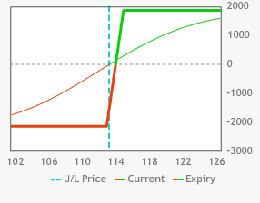

GRAPH70

AAPL Short Sep 119-115 call spread

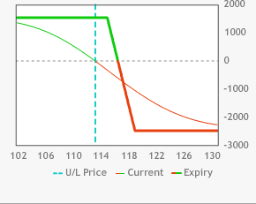

GRAPH71

AAPL Sep 113-115-119 uneven call butterfly

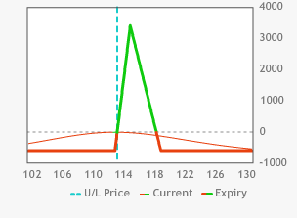

Another kind of butterfly is the skip strike butterfly. Unlike the uneven butterfly, the upside and downside risks are not equally calibrated. In this spread the bull spread and the bear spread are traded an equal number of times, even though there is a differential in the width of their strike prices.

Look at the IBM Oct 150-155 1x2 call spread. The 150 calls are offered at 4.10 while the 155 calls are bid at 2.05. You can establish the spread for even money. There is no downside risk, however the losses run forever above 160.

GRAPH72

IBM Oct 150-155 10x20 call spread

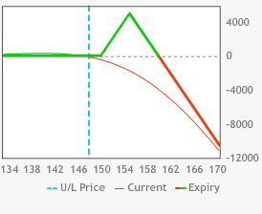

You could buy ten Oct 160 calls at 0.98 to make it a normal butterfly. Your losses would be limited to 0.98 ($980) on both the upside and the downside.

GRAPH73

IBM Oct 150-155-160 long call butterfly

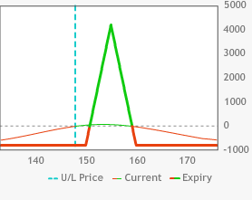

Instead of buying the IBM Oct 160 calls at 0.98 for protection you could skip a strike and buy the Oct 165 calls at 0.42. Your maximum downside loss would be reduced to 0.56 ($560). Your maximum upside loss would rise to $5,560 as a result. This is a strategy that is best used when the underlying product’s downside moves are much more rapid than their upside moves.

GRAPH74

IBM Oct 150-155-165 skip strike call butterfly

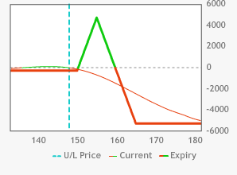

**Collars**

On May 18th2012 Facebook (FB) opened at 42.05, trading as high as high as 45.00, as low as 38.00 while closing at 38.23. On September 4th, 2012 FB traded as low as 17.55 while closing at 17.73. All of those who were expecting to double their money within a week after its first day of trading were nowhere to be found. On August 26th, 2015 FB closed at 87.19, 12.05 points off its high. You bought 1,000 shares of FB at 27.19 back in 2012. That is a $60,000 profit. You think that FB will get back to its previous high, but you have also been spooked by FB selling off its high.

GRAPH75

Long 1,000 shares of FB @ 87.19

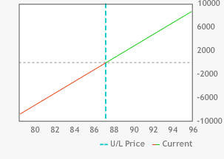

You want to define your losses, so you buy ten FB Oct 77.50 puts at 2.15. That means that any price below 75.35 is pure profit. That cancels out any losses in your long stock position below 75.35. You have created a synthetic long call at 12.15 (not including interest). Your breakeven point to the upside is 2.15 higher than it is for staying strictly long the stock. Your maximum loss is now $11, 840 instead of $87,190. You have converted your long stock position into a long call position.

GRAPH76

Long 1,000 shares FB + long 10 FB Oct 77.50 puts

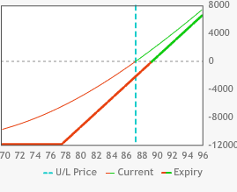

To help finance the purchase of your Oct 77.50 put you sell ten FB Oct 97.50 calls at 1.56. The cost of the collar is only 0.59, costing $590. This means that you no longer profit to the upside above 96.91. You have now converted your long call position into a long (bull) vertical call spread.

GRAPH77

Long 1,000 shares FB + long 10 FB Oct 77.50 puts + short 10 FB Oct 97.50 calls

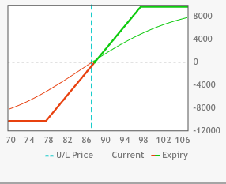

Another way to look at it is as a short (bull) vertical put spread. Long stock coupled with a short 97.50 call is a synthetic short put. Coupling that with the long 77.50 put creates the put spread.

**Time Value Spreads**

Since you have learned about vertical spreads (the simultaneous purchase and sale of the same type (put or call) of options of the same expiration cycle but different strike prices) it’s now time for you to learn about *time value* spreads. These spreads are also known as *calendar* or *horizontal (time horizon)* spreads. *Long time value spreads* occur when you go *long* an *option* in a deferre*d expiration cycle* while *simultaneously* going *short* another *option* of the *same strike price* in a *more nearby expiration cycle.*

Why are they called time value spreads? Look at the NFLX Oct-Sep120 call spread with NFLX at 123.39. The premium for the NFLX Oct 120calls is 12.50. The premium for the Sep120 calls is 7.90. The expiration value for both calls is 3.39. *Every option* of the *same strike price* will have the *same expiration value* regardless of when the expiration cycle occurs. The difference between the respective *time values* *creates* the *spread*.

When you are long a time value spread you want to take advantage of the decay in the time value of the nearby month. Look at the previously mentioned, long NFLX Oct-Sep 120 call spread. The Sep options expire in 35 days while the Oct options expire in 63 days. When NFLX is trading at 130 at the end of the Sep expiration cycle, that means that you will be assigned on the short NFLX Sep 120 calls which will then morph into short stock. You will be left with a position of short NFLX stock against long NFLX Oct 120 calls. That works out to be a synthetic long NFLX Oct 120 put position.

When NFLX is trading at115 at the end of the Sep expiration cycle the short Sep calls would then go out worthless. You would be left with a position of long the NFLX Oct 120 calls.

GRAPH78

Long NFLX Oct 120 calls

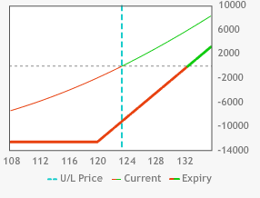

GRAPH79

Short NFLX Sep120 calls

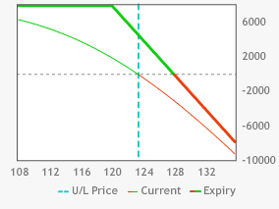

GRAPH80

Long NFLX Oct-Sep 120 call spread

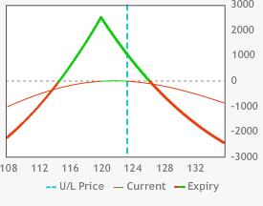

Look at the long NFLX Oct-Sep120 put spread. The premium for the NFLX Oct puts is 9.00. The premium for the Sep 120 puts is 4.50. The expiration value for both puts is zero. The premium for both puts consists of purely time value. When NFLX is trading at 130 at the end of the Sep expiration cycle the Sep puts would finish OTM and therefore go out worthless. You would be left with a position of long NFLX Oct 120 puts.

When NFLX is trading at 115 at the end of the Sep expiration cycle the Sep 130 puts will finish ITM and you will therefore be assigned. The short puts will morph into long stock. You will be left with a position of long NFLX stock in tandem with long NFLX Oct 120 puts. You would consequently be left with a position of long the synthetic NFLX Oct 120 calls.

GRAPH81

Long NFLX Oct 120 puts 10x

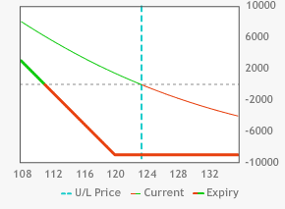

GRAPH82

Short NFLX Sep 120 puts 10x

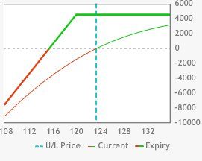

GRAPH83

Long NFLX Oct-Sep 120 put spread 10x

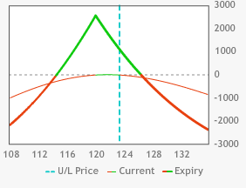

As you can see the long, put time value spread acts just like the long call time value spread. What is the perfect price point for a long, time value spread? Whenever you are *long* an *option* you *want* it to go to *infinity*. Whenever you are *short* an *option* you *want* it to go out *worthless*. The *highest value* for your *long* NFLX Oct 120 *calls while* your NFLX Sep 120 *short calls* are *worthless* is *at 120*. Anything *above 120* means that the *short Sep calls* will be going *up* in *price* along *with* the *long Oct calls*. At any price *below 120* the *short Sep 120 calls* will be *equally worthless* but the *long Oct 120 calls* will be *losing value* with *each down tick* in NFLX. That means that when NFLX travels to 140 both the long and short calls will be deeply ITM. Their premium will be comprised almost entirely of expiration value and the spread will narrow in price. When NFLX travels to 100 both the long and short calls will be deeply OTM. Their premium will be comprised entirely of time value, with almost all of it wiped out. Once again, the spread’s price will have narrowed substantially. Conversely when you are *short* a *time value spread* you want the *stock* to *move as far away from the strike as possible*.

A long ATM time value spread would benefit from a period of consolidation. What time value spread would be bearish? Remember time value spreads are at their max value when they are ATM. An *OTM long put time value spread* would therefore be a *bearish* strategy. Its value would increase the closer that it goes to the lower strike price. With FB trading at 80.29 the Aug 75 puts are offered at 1.78 and the Jul 75 puts are a 0.63 bid. As FB heads to 75 the value of the spread increases beyond the initial value of 1.15. If it gaps well below 75 then its value begins to decline again.

GRAPH84

Long FB Jul-Jun 75 put spread 10x

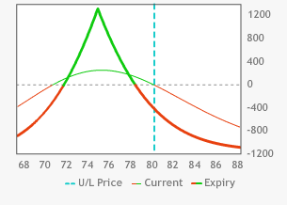

What time value spread would be bullish? An *OTM long call time value spread* would be a *bullish* strategy. Its value would increase the closer that it goes to the higher strike price. With FB trading at 80.29 the Aug 85 calls are offered at 2.00 and the Jul 75 calls are a 0.71 bid. As FB heads to 85 the value of the spread increases beyond the initial value of 1.29. If it gaps well below 85 then its value begins to decline again.

GRAPH85

Long FB Aug-Jul 85 call spread 10x

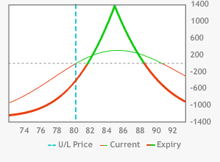

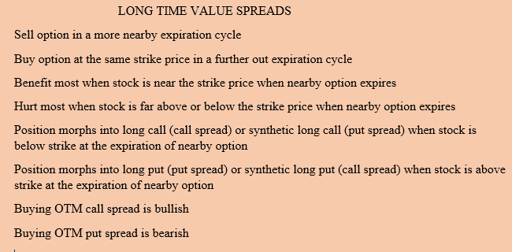

Look at the TSLA Sep-Oct 250 call spread with TSLA at 248.48. The premium for the TSLA Oct 250 calls is 16.05. The premium for the Sep 250 calls is 10.90. There is no expiration value for either call. Once again, every option of the same strike price will have the same expiration value regardless of when the expiration cycle expires. It is the respective time values that create the spread.

When you are short an ATM time value spread you want to take advantage of big move in the underlying stock. Look at the aforementioned short TSLA Sep-Oct 250 call spread. The Sep options expire in 18 days while the Oct options expire in 46 days. When TSLA is trading at 265 at the end of the Jun expiration cycle you will then exercise your long, TSLA Sep250 calls and they will morph into a long stock position. You will be left with a position of long TSLA stock against the short TSLA Oct250 calls. That works out to be a synthetic short TSLA Oct 250 put position.

When TSLA is trading at 235 at the end of the Sep expiration cycle then the long Sep calls would go out worthless. You would be left with a position of naked short the TSLA Oct 250 calls.

GRAPH86

Long TSLA Sep 250 calls 10x

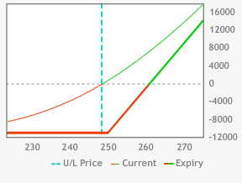

GRAPH87

Short TSLA Oct 250 calls 10x

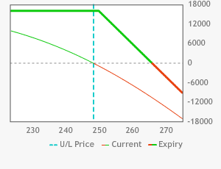

GRAPH88

Short TSLA Sep250-Oct 250 call spread 10x

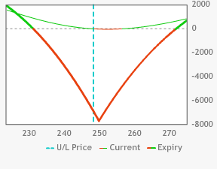

The strike price is the dead zone for the short time value spread. The long call is still as worthless at 250 as it is at 245 but your short call is at a much higher price. Above 250 your long call is appreciating along with your short call. You are hoping for a volatile market when you are short a time value spread.

Look at the short TSLA Sep-Oct250 put spread. The premium for the short TSLA Oct250 puts is 35.70. The premium for the long Sep250 puts is 14.40. The expiration value for both puts is 0.55. TSLA is trading at 260 at the end of the Sep expiration cycle. The Sep 250 puts would finish OTM and go out worthless. You would be left with a position of naked short the TSLA Oct 250 puts.

When TSLA is trading at 240 at the end of the Sep expiration cycle the Sep 250 puts will finish ITM and will be exercised as a result. The long puts will morph into short stock. You will be left with a position of short TSLA stock in tandem with the short TSLA Oct 250 puts. You would consequently be left with a position of short the synthetic TSLA Oct 250calls.

GRAPH89

Long TSLA Sep 250 puts 10x

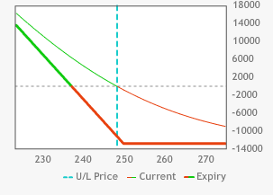

GRAPH90

Short TSLA Oct 250 put 10x

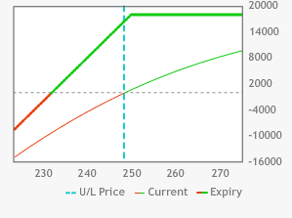

GRAPH91

Short Sep-Oct 250 put spread 10x

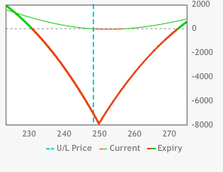

As you can see, the short, put time value spread acts just like the short call time value spread. What is the perfect price point for a short time value spread? There is no perfect price point but there is a catastrophically bad price point. Whenever you are long an option you want it to go to infinity. Whenever you are short an option you want it to go out worthless. You like it if your Jun 250 calls go out worthless. That works well if your short Jul 250 calls have taken a beating in price. That means that when there is no time value in your long calls while your short calls have lost most, or their entire time value. The time value spread has therefore narrowed. You also like it if your short Jul calls go up dramatically. When that happens both your long and short calls will be deeply ITM and have very little, if any time value left in their respective premiums. Consequently, the time value spread will have narrowed. The lowest value that the long TSLA Jun250 calls can be while the short TSLA Jun 250 calls are at their highest value is at 250.You want TSLA as far away from the strike price as possible. You don’t care if TSLA goes up or down. You just want TSLA to make a big move away from the strike price.

A variation of a time value spread is the diagonal spread. With the diagonal spread you are selling a front month option at one strike price while buying an option in a further out expiration cycle at a different strike price. With C trading at 53.28, twenty-five Sep56 calls are being shorted at 0.52 while a long position is established in twenty-five of the Oct 57.50 calls at 0.72. If C settles below 56 at the Sep expiration the remaining position is long the Oct 57.50 calls. If C closes above 56 at the Sep expiration, then the short Sep 56 calls will be assigned, resulting in a short stock position. In that case you have created a long synthetic Oct 57.50 put position.

The sweet spot for this spread is at 56. The short calls go out worthless while the long calls are at their highest value while the short calls are still worthless.

The most that can be lost to the downside is 0.20 ($500). The greatest upside loss is 1.70 ($4,250). You add the differential in the respective strike prices to the debit for the spread to arrive at that number. This example has the same number of long and short options. The risk is to the upside so a trader will frequently go net long more calls in order to change the risk profile.

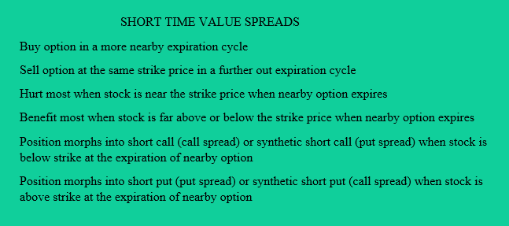

GRAPH92

Long C Oct 57.50 calls25x

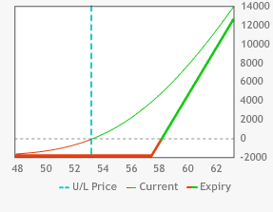

GRAPH93

Short 25CSep 56 calls

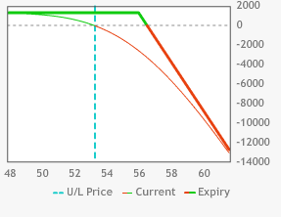

GRAPH94

C Oct 57.50-Sep 56 call diagonal spread 25x

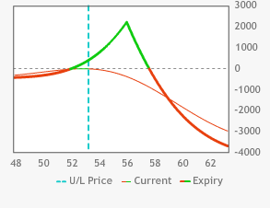

INTERMEDIATE OPTIONS QUIZ

1. When you are long 10 PEP Oct 92.50 calls for 1.50 and short 10 PEP Oct 95 calls for 0.65 you have established a _________________.
2. time value spread
3. vertical spread
4. pre-game spread
5. margarine spread
6. When you are long 10 TSLA Dec260 calls for 25.60 and short 10 TSLA Oct 260 calls for 11.80 you have established a _________________.
7. time value spread
8. vertical spread
9. pre-game spread
10. margarine spread
11. What is the net premium for the spread in Question #1?
12. 2.15 credit
13. 2.15 debit
14. 0.85 debit
15. 0.85 credit
16. What is the maximum possible value for the spread in Question #1?
17. unlimited
18. 7.50
19. 2.50
20. 5.00
21. What is the minimum possible value for the spread in Question #1?
22. zero
23. 7.50
24. 2.50
25. 5.00
26. What is the maximum possible profit for the spread in Question #1?
27. 1.50
28. 0.65
29. 2.15
30. 1.65
31. What is the maximum possible loss for the spread in Question #1?
32. 1.50
33. 0.65
34. 0.85
35. 1.65
36. The spread in Question #1 is ______________________.
37. bullish
38. bearish
39. neutral
40. indecisive
41. When you are long 10 TGT Oct57.50 puts for 1.55 and short 10 TGT Oct 60 puts for 3.00 you have established a _________________.
42. bear vertical put spread
43. bull vertical put spread
44. neutral vertical put spread
45. indecisive vertical put spread
46. The spread in Question #9 begins to reach its maximum profitability at_____?
47. 65.00
48. 57.50
49. 60.00
50. 52.50
51. The spread in Question #9 begins to reach its maximum loss at_____?
52. 65.00
53. 57.50
54. 60.00
55. 52.50
56. Regarding the spread referenced in Question #2, if TSLA closes at 290 on Oct expiration you are left with a position of a______________________.
57. long Oct 260 call
58. long Oct 260 synthetic put
59. long Dec 260 call
60. long Dec 260 synthetic put
61. Regarding the spread referenced in Question #2 If TSLA closes at 230 on the Oct expiration you are left with a position of a______________________.
62. long Oct 260 call
63. long Oct 260 synthetic put
64. long Dec 260 call
65. long Dec 260 synthetic put
66. If you were bullish on TSLA the best spread for you would be the ___________.
67. long TSLA Dec 260 – Oct 260 call spread
68. long TSLA Dec 260 – Oct 260 put spread
69. long TSLA Dec 230-Oct 230 put spread
70. long TSLA Dec 290 – Oct 290 call spread
71. Referring to the spread referenced in Question#2 where would you want the stock to close on the Oct expiration?
72. 230
73. 260
74. 290
75. 310
76. When you short the CAT Sep 105 straddle for 4.20 your upside breakeven point is _________________.
77. 100.80
78. 105.00
79. 113.40
80. 109.20
81. What is the maximum possible downside loss for the trade in Question #16?
82. 4.20
83. 105.00
84. 100.80
85. 109.20
86. What is the ideal price point for the trade in Question #16 at the Sep expiration?
87. 105.00
88. 100.80
89. 109.20
90. 96.80
91. When you are long the CAT Sep 110 call – Sep 100 put strangle for 1.05 what is the upside breakeven point?
92. 105.00
93. 112.50
94. 111.05
95. 101.05
96. When you combine the trade in Question #16 with the trade in Question

# 19 what position did you establish?

1. iron condor
2. steel eagle
3. chrome hawk
4. iron butterfly
5. What is the ideal price point for the trade in Question #19 at Sep expiration?
6. 100.00
7. 105.00
8. 110.00
9. 115.00
10. What is the maximum possible loss for the trade in Question #19?
11. 4.20
12. 1.05
13. 3.10
14. 1.90
15. When you short the CAT Nov 90 - 80 put spread for 0.35 and the Nov 120 – 130 call spread for 0.20 your maximum possible profit is _______________?
16. 0.15
17. 0.55
18. 1.55
19. 1.15
20. What is the maximum possible loss for the trade in Question #23?
21. 19.45
22. 5.45
23. 9.55
24. 9.45
25. What is the name of the trade in Question #23?
26. iron condor
27. steel eagle
28. chrome hawk
29. iron butterfly
30. When you are long the SBUX Oct 80 – Oct 77.50 put spread for

1.30, while being short the SBUX Oct 75 - Oct 77.50 put spread for 1.05

you have created a_______________.

1. long iron condor
2. short chrome hawk
3. long put butterfly
4. short put butterfly
5. What is the ideal price point for the trade in Question #26 at the Oct expiration?
6. 75.00
7. 80.00
8. 77.50
9. 72.50
10. What is the maximum possible loss for the trade in Question #26?
11. 2.50
12. 2.25
13. 0.50
14. 0.25
15. When you combine a long MCD Oct 95 – 100 call spread for 1.25 with a long MCD Oct 100 – 95 put spread for 3.70 you have created a _____________.
16. long mixed vertical
17. long box
18. short box
19. short mixed vertical
20. What will be the profit or loss for the trade in Question #29 at the Oct expiration?
21. 3.70 profit
22. 1.25 loss
23. 4.95 loss
24. 0.05 profit

INTERMEDIATE QUIZ ANSWER KEY

1. b

Long vertical call spread that maxes out at 95.00 or higher.

2) a

A time value spread is a long and a short with the same strike price and class (puts or calls) but different expiration cycles.

1. c

When the long has a higher premium than the short there is a debit.

4) c

You figure out the maximum value by determining the difference in the strike prices.

5) a

At 95 and below both calls are worthless.

6) d

You take the max value and subtract the debit.

7) c

In a straight vertical, spread you the most that you can lose is the debit. It occurs in this case 292.50 and below.

8) a

You are long the lower strike call and short the higher strike call. The lower strike will always have more value unless they are both worthless.

9) b

The lower strike put will always have less value than the higher strike put.

10) c

At 60 both puts are worthless which maxes out profits.

11) b

At 57.50 spread hits max value of 2.50.

12) d

Your short Oct 260 calls are assigned and morph into short stock. Long call plus short stock is equivalent to a long put.

13) c

Your short Oct 260 calls go out worthless and you are left with a naked long Dec 260 call.

14) d

Time value spreads are always at their max value when they are ATM. An OTM time value spread is therefore bullish.

15) b

At 260 your short calls are at the highest price point in the stock while still being worthless.

16) d

The credit from both options is added to the strike price in either direction in order to determine both the upside and downside breakeven points.

17) c

The short 105 puts are worth 105 when the stock goes to zero. The 4.20 credit softens the blow somewhat.

18) a

Both your short puts and calls are worthless.

19) c

The debit from both options is added to the strike price in either direction That determines both the upside and downside breakeven points.

20) d

A short straddle combined with a long strangle creates a long iron butterfly.

21) b

It is the same as the short straddle but with insurance and the costs that come with it.

22) b

With long options you can only lose the premium that you paid.

23) b

With short options the max profit is the net credit at the start of the position.

24) d

You are short two separate $10 verticals. When one of them is ITM the other, by definition, is OTM. Subtract the credit from 10 and you have your answer.

25) a

An iron condor is shorting an OTM vertical put spread and a same size OTM vertical call spread equidistant from the price of the underlying stock.

26) c

Combining a higher strike long put vertical with the next lower strike short put vertical is a long, put butterfly.

27) c

The middle strike price in a long butterfly is the max value. Your long vertical is at max value while your short vertical is at min value.

28) d

The debit in a long butterfly is the max possible loss. That happens when both verticals are both at max value or min value.

29) b

When you combine a $5 long put vertical with a $5 long call vertical you have a combination that will always be worth 5 at expiration.

1. d

When one vertical is worth 5 the other is worthless. When one is worth 2 the other is automatically worth 3.

**ADVANCED SECTION**

**The Greeks**

The prices of stocks are determined by an almost unlimited set of variables; supply and demand affected by earnings reports, market psychology, investment bank recommendations, rumors, etc. You earlier learned about pricing models and how they attempt to quantitatively determine the effect that the variables like underlying stock price, interest rates, volatility, and time have on premium. We’ll now learn about the risk control tools that every professional trader uses. These tools are called the “Greeks”.

*Delta, Gamma, Theta, Vega and Rho* are the Greeks. No, this isn’t an Animal House movie review. These are the Greek symbols that represent mathematical formulas that traders use to properly evaluate their position. How the Greeks are arrived at will not be taught here. Like pricing models, the various Greeks are available to traders from their trading platforms.

Every one of these *Greeks* estimates the risk for one variable: *Delta* indicates the change in the *option value due* to a *one-point change* in the *underlying stock price*. *Delta* also measures the *percentage chance* of an *option finishing ITM* at *expiration*. Finally, *delta measures* what *percentage* of *stock* it *represents*. This is called *equivalent share position or ESP. Call deltas* are *always* a *positive number* and *put deltas* are *always* a *negative number*.

G*amma* is a derivative of delta. *Gamma* indicates the *change* in the *option delta* due to a *one-point change* in the *price* of the *underlying stock*. Gamma is always a positive number. *Theta* measures the change in the option value due to one day’s erosion in time value. Theta is always a negative number. V*ega* measures the *change* in the *option value* due to a *change* in the *implied volatility* (or price level of the time value embedded in an option premium) of the options. *Vega* is *always* a *positive number*. *Rho* measures the *change* in the *option value* due to a *change* in *interest rates*. *Rho* is *always* a *positive number*.

**Delta**

Let’s start out with deltas. Call options always have a positive delta. Put options always have a negative delta. A call delta of 0.50 means that for every 1.00 the underlying stock increases, the call option value will increase by 0.50. A 0.50 delta also means that for every 1.00 decrease in the value of the stock the call option value will decrease by.50. Call options deltas have a range from 0.0 to 1.00. Put options always have a negative delta. A - .50 delta means that for every 1.00 the underlying stock decreases the put option will increase 0.50 in value. A -.50 delta also means that for every 1.00 increase in the value of the stock the put option value will decrease by 0.50. Put options have a delta range from 0.00 to –1.00.

Here are a few more guidelines regarding deltas. An ATM call has a delta around .50. The delta for a call option rises the further the underlying stock *rises above* the strike price and falls when it drops below the strike price. Conversely, the negative delta for a put rises the further the underlying price falls below the strike price and declines when it rises further above the strike price.

When a call is deep enough ITM, its delta can approach 1.00. When a put is deep enough ITM, its delta can approach -1.00. In each of these cases your options are appreciating or depreciating at the same rate as equivalent shares of stock. The delta for a put option drops (to a lower negative number) the further the underlying stock rises above the strike price. The delta for a call option drops the further the underlying stock drops below the strike price. When a put or call is far enough OTM its delta can approach zero. A zero delta means that your option is so far OTM that it would require a drastic change in the price of the underlying stock just to affect the price of the option.

It would theoretically have no chance of finishing ITM at expiration. Having traded over five different decades I can assure you that I’ve seen calls with a1.0 delta finish OTM and zero delta puts finish ITM. So how does delta help you determine equivalent share position (ESP)? And just what is *ESP*? *ESP* is a measurement of how many shares of stock your options position is equivalent to; and delta is the instrument you use to determine ESP.

For example, if you owned two ATM call options, potentially representing two 200 shares of stock with a delta of .50, your option position is the equivalent of being long 100 shares of stock. Think about it and it makes sense. When you are long two FB Aug 72.50 calls with a premium of 3.30 with FB at 72.50 and a delta of 0.50, a two point move in FB to 74.50 would result in the premium rising to 4.30. That would mean your option position increased by $100, which is the same profit you would gain by being long 100 shares of stock. Those 1.00 ESP might also be referred to as one hundred shares or simply as 100 *deltas.*

So why not just buy 100shares of stock and be done with it? Don’t forget about our old friend leverage. Like we talked about in earlier chapters, options give you more bang for the buck. In the previous example 100 shares of FB @72.50 would require margin (REG-T 50%) of $3,625.00while being long 2 FB Sep 72.50 calls at 3.30 would require $660, but you would net just as much with two of the options as you would with 100 shares of stock. As an added bonus there would also be a defined risk to the downside ($660 vs. $7,250).

Here are some examples of using delta to determine how premium will change when the underlying stock moves: CVX Sep 125 calls are trading at 2.50 with a delta of 0.50 when CVX is trading at 125.00. What will the CVX Sep 125 calls be worth when CVX rises to 126.20? If you answered 3.10 then move to the head of the class. If you didn’t answer correctly then take the 1.20 increase in price of CVX and multiply it by the 0.50 delta whereby you add 0.60 to the previous premium of 2.50 to arrive at the new premium of 3.10.

What would the CVX Sep125 calls be worth when CVX drops to 123.50? If you answered 1.75 then you get a gold star planted on your forehead. Since the price change is 1.50 you subtract 0.75 (1.50X0.50) from 2.50 and you get 1.75.

Let’s use the example of the CVX Sep 125 puts that are worth 3.40 when CVX is trading at 125.00, with a delta of -0.50. What happens to the premium when CVX drops to 124.20? The correct answer is 3.80. CVX dropped 0.80 so you multiply the movement in the stock (0.80) by the delta (-0.50) and add that to 3.40 and you wind up with a premium of 3.80.

How about using the same example, but with CVX rising to 125.80? It is the same move except in the opposite direction (a direction that is unfriendly to the value of puts) so the new premium for the CVX Sep 125 puts is 3.00.

Can you use delta in figuring spread value? You can bet your bottom dollar that you can. Let’s look at the CVX Sep125-130 vertical call spread with CVX at 124.70. The premium for the Sep 125 calls is 2.42 with a delta of 0.44. The short July 130 calls, trading at 0.82, have a delta of 0.21. The combined delta for the CVXSep125-130 vertical call spread is 0.23(0.44-0.21). The current value for the spread is 1.60. When CVX rises to 125.60 the next day the spread’s value will rise to 1.81 (0.90 X0.23). Now, let’s look at the CVXSep120-115 vertical put spread with CVX trading at 125.20. The premium for the CVX Sep 120 puts is 1.55 with a delta of -0.30 while the Sep115 puts are valued at 0.70, with a -0.15 delta. The net premium for the spread is a debit of 0.85. The combined deltas add up to -0.15, so when CVX rises up to127.00 the value of the spread will decline in price to 0.58.

Now let’s try a more complicated example of *ESP.* What happens, with CVX at125.25 when you are short 400 shares, long 10 CVX Sep 125calls with a delta of 0.47, short 7 Sep 115 puts with a delta of -0.12, and long 5 Oct 120 puts with a delta of -0.27. What would your ESP be?

Your ESP would be positive 0.19 deltas. Did you come up with that? You start out short 400 shares outright (-400 deltas). Go long 10 Sep 125 calls (470 deltas). You then short 7Sep 115 puts (84 deltas). You go long 5 Oct 120 puts (-135 deltas).

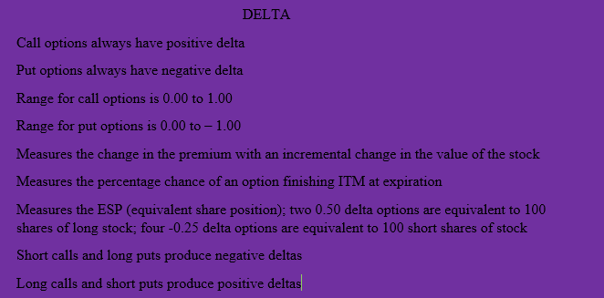

**Gamma**

The next *Greek* that you need to know about is *gamma*. *Gamma* is a *derivative of delta*. Gamma measures how the *delta* of an option will change *relative to a 1 point move* in the underlying stock. *Gamma* is *always* a *positive* number.

The *further away from the stock* (up or down) a strike price is, the *smaller the gamma* is. If an option is deeply ITM or distantly OTM, the gamma is small. If the option is *ATM*, then *gamma* is at its *highest*. The closer that an option is to expiration the gamma grows if it is near the money and shrinks if it is OTM. An ATM option on expiration day has a massive gamma.

Long calls and long puts have positive gamma. When you have a *positive gamma* position your *ESP* will acquire *more positive deltas* as the underlying *stock price rises* and acquire more *negative deltas* as the underlying *stock price declines*.

Short calls and short puts create a negative gamma position. When you have a *negative gamma* position your *ESP* will *acquire* more *negative deltas* as the underlying *stock price rises* and acquire more *positive deltas* the underlying *stock price declines*.

Let’s look at a long CVX Aug 125 call with a delta of 0.50 and a gamma of 0.10. CVX is currently trading at 125.00. When CVX runs up to 126.00 then the delta for the 125 calls increases to 0.60. You simply add the 0.10 to the existing 0.50 delta to come up with the new delta of 0.60. With CVX now 1.00 higher there is now a 60% chance that the Aug 125 calls will finish ITM at expiration versus a 50% chance when the stock is trading at 125. When CVX drops in price to 124.00 you subtract the 0.10 gamma from the 0.50 delta to come up with the new delta of 0.40. With CVX now 1.00 lower at 124 there is now a 40% chance that the Aug 125 calls will finish ITM at expiration versus a 50% chance when the stock is trading at 125.

What happens when CVX makes a 0.50 move to the upside? You multiply the 0.50 move by the gamma of 0.10 and add 0.05 to the existing delta of 0.50 to come up with the new delta of 0.55. When the 0.50 move is to the downside then you subtract the 0.05 to come up with the new delta of 0.45.

Look at the CVX Aug 125 puts with a delta of -0.50 and a gamma of 0.10. When CVX runs up to 126.00 the new put delta declines 0.10 to a new delta of – 0.40. When CVX travels down to 124.00 the new put delta increases to -0.60.

What happens when CVX makes a 0.50 move to the upside? You multiply the 0.50 move by the gamma of 0.10 and add 0.05 to the existing delta of 0.50 to come up with the new delta of 0.55. When the 0.50 move is to the downside then you subtract the 0.05 to come up with the new delta of 0.45.

Look at a scenario involving a negative gamma position when you are short a CVX Oct 120 put, with CVX at 125.00. In this case your delta is -0.34 with a gamma of 0.04. What is the new delta when CVX runs up to 127.00? Your new delta is 0.26(2.00 x -.04) = (-0.08) - (-0.34) = -0.26. What is the new delta when CVX drops to 123.00? Your new delta is 0.42(2.00 x -.04= -0.08 + (-0.34) = -0.42. OK, let’s look at the short straddle. When you are short the straddle you have negative gamma because you are short both calls and puts. It makes sense when you take the time to think about it. Using the CVX Oct 125 short straddle you can see that when CVX heads straight up your short Oct 125 calls will pick up negative delta (because you are short a positive delta) as they become deeper and deeper ITM while your short Oct 125 puts lose positive (or short negative) deltas as they become further OTM.

OK, now let’s look at the flipside when CVX heads straight downhill. The short Oct 125 puts will continually pick up positive (or short negative) deltas. The short Oct 125 calls will continue to be further and further OTM and therefore lose their negative or short positive, deltas.

What happens when you are long the CVX Oct 125 straddle with CVX trading at125? The ATM call would have a 0.50 delta while the ATM put would have a - 0.50 delta. You would have a *delta neutral* position. Both the call and put have a *positive* gamma of .04.

What happens when CVX runs up to 128? Your delta of 0.50 increases to 0.62 (0.50 + (3.00X.04)) for that three, point move. Your -0.50 delta would decrease to -0.38 (-0.50 -(3.00X.04)) for that three, point move. Your Oct 125 calls now have a delta of 0.62 while your Oct 125puts have a delta of -0.38. Your formerly delta neutral position would now be positive 0.24deltas. As CVX goes further up the rate at which CVX acquires positive deltas continues to diminish (remember gamma is at its highest when the underlying stock is closest to the strike price).

What happens when CVX drops down to 122 your 0.50 delta would decrease to 0.38 (0.50 - (3.00X.04)) for that three, point move. Your -0.50 delta would increase to -0.62 (-0.50) +(3.00X.04)) for that three, point move. Your Oct 125 calls would now have a delta of 0.38 while your Oct 125 puts would have a delta of -0.62. Your formerly delta neutral position would now be negative 0.24 deltas. As CVX goes further down the rate at which CVX acquires negative deltas continues to diminish (remember gamma is at its highest when the underlying stock is closest to the strike price).

Well, if being positive gamma means that you get longer when the stock goes up and shorter when the stock goes down then it stands to reason that you should always be positive gamma. That makes sense, doesn’t it? Wrongo!!! There is another Greek that you need to learn about. *Theta* is covered in the next chapter.

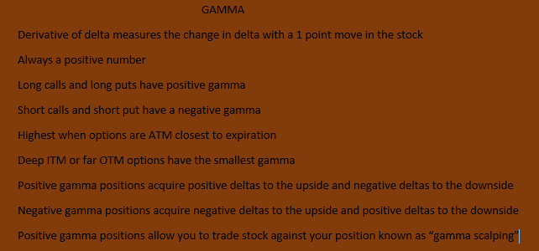

**Theta**

*Theta* is a measure of how much the *time value* of an option *decreases* when *one day* passes and there is no move in either the price or implied volatility of the underlying stock. It is also referred to as *daily decay or time erosion*.

Think back to the previous chapter. Do you remember how a positive gamma position seemed like the only logical position to have? It is true that having a positive gamma position has its advantages when the stock is actively going either up, down or both. You do, however, pay for those advantages. That payment, as you know, is called premium.

As you learned earlier, premium is broken down into two components. One is expiration value and the other is time value. Stock is 100% expiration value. Stock has no daily decay.

Look at the CAT Sep95 calls, priced at 7.40 with CAT at 101.35. The premium of 7.40 is comprised of an expiration value of 6.35 with the remaining 1.05 being time value. As expiration draws nearer that time value will diminish and the only remaining premium will be the expiration value. The CAT Sep 95 put is priced at 0.70. Since it is *OTM* its premium is *100%, time value*.

As an option approaches the end of its expiration cycle its time value declines more rapidly since the probability of that option being ITM is reduced. During the last one to two months before expiration there is a greater rate in time value’s erosion. Think of theta as an ice cube. It melts most rapidly towards the end of its existence. The greatest amount of theta occurs when an option is ATM. Expiring 0.50 (or -0.50) delta options (both puts and calls) have the highest theta.

Take a moment to think about it. Time value is based upon uncertainty. If an option has a 0.90 delta, we know that it is very deeply ITM and it is reasonably certain to stay that way (90% degree of certainty). When you are long the CATSep100 straddle amd the stock stays in a tight range your position will lose money day after day. With each passing day the time value will be worth less and less at an increasing rate.

When you are *long options* that means that you are *negative theta*. When you are *short options* that means that you are *positive theta*. As the time value erodes, so does the price of the premium and ultimately the balance in your trading account when you are negative theta in a sleepy market. The CAT Sep 100 calls are priced at 3.50 with a theta of 0.03. That means that all other things being equal those calls will decline in price to 3.47. The CAT Aug 100 weekly calls, priced at 1.85, with two days left until expiration have a theta of 0.143. That is more than four times the rate of decay of the Sep options. The time value is 0.50.

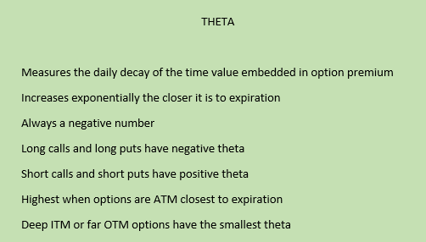

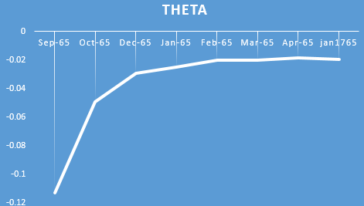

**Vega**

Vega *measures the sensitivity* of your position to *changes in implied volatility (IV).* What is IV? Let’s first figure out what historical volatility (HV) is. One simple method is to see volatility as representing a one standard deviation move in the stock price in one year. Approximately two-thirds of the occurrences will be within plus one and minus one standard deviation. A volatility of 40% means that the commodity will theoretically be within approximately plus 40% or minus 40% two-thirds of the time. If BA is trading at $100, and volatility is 40%, two-thirds of the time the stock will be between approximately $60 and $140. If the volatility is 20% then it will trade between 80 and 120 two-thirds of the time.

That is *historical* volatility. *Implied* volatility is another matter. *IV* is a *reverse engineering process* whereby you plug into a theoretical option, pricing model the current option prices that makes the *theoretical* value *equal to* the *market* value of the option. An option pricing formula uses the stock price, strike price, interest rate, time to expiration, and volatility to calculate a theoretical option value. The supply and demand of an option will result in it trading at a certain price. That *price* reflects or *implies* what the *volatility of the underlying stock will be in the future.* The *market* is *implying* what the *future volatility* will be. HV and IV are rarely on the same page. A decision needs to be made as to which one makes the most sense for your trading at any given moment.

Look at an ATM straddle as an example. Another way to look at IV is to compare it to the over/under in a football game when the over/under in an upcoming football game is 92 between two high scoring teams. If you bet the over, you are like a trader who believes that the IV will remain at its current level or go higher. If you bet the under you believe that the current time value that is embedded in the options premiums will decline.

A *positive vega* position is one that is *net, long time value*. A position that is *long options* will be a *positive vega* position. A position that is *short options* will be a *negative vega* position. A position that is *long further out options* and is *short the nearby ones* is a *positive vega* position. *Positive vega* means that the *value* of an *options position increases* when *IV increases* and *decreases* when *IV decreases*; *negative vega* means that the *value* of an *options position decreases* when *IV increases*, while *increasing* when *IV decreases*.

You buy a truckload of oranges that will be sold over the following week. There is then a big freeze in Florida and the supply of oranges shrinks. Suddenly, the value of your inventory increases. That is an example of a positive vega position. If you had bought your oranges while there were fearful weather reports that never materialized the value of your inventory would decline once the uncertainty vanished.

As with both *gamma* and *theta*, *vega* is at its *highest* when an *option* is *ATM*. *ATM options* have the *highest* amount of *time value*. The *further out* an *expiration cycle* is the *greater the vega* will be for its options. The vega for an ATM May 100call will not be as great as the vega for an ATMJuly100call. The further out on an expiration calendar the more time value there will be in the options since there is more time for something crazy to happen. A quick way, therefore, for a trader to adjust to their positive *vega* position is to short some options that expire at a later date than their current inventory of options.

You will use vega to help manage the risk in your position that is attributable to IV. When your position has a positive vega of 250 and IV increases three points your account will theoretically grow by $750. When IV decreases two points with the same position your account will contract by $500. When you have a negative vega of 175 and IV decreases six points your account should grow by $1,050. When IV increases four points with the same position your account will contract by $700.

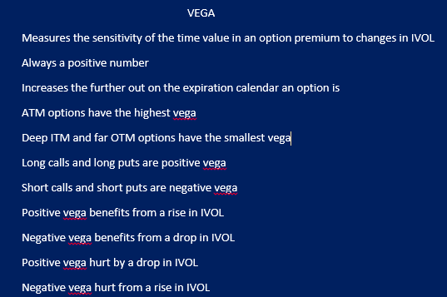

**Rho**

The last Greek that we’ll cover is *rho*. It measures the effect of interest rates on the value of an option. The more expensive it is to hold a stock position, the more expensive the call option. An *increase* in *interest rates increases* the *value* of *calls* and *decreases* the *value* of *puts*. A *decrease* in *interest rates decreases* the *value* of *calls* and *increases* the *value* of *puts*. You are *positive rho* if you are either *long calls* or *short puts*. You have a *negative rho* position if we are either *long puts* or *short calls*.

When you establish a long position in a stock you are either margining part of the transaction (paying interest) or paying cash (and forgoing interest). When you go long a call the capital commitment is less so there is less interest being debited from your account. A rise in interest rates means that holding stock is more expensive. That, in turn, raises the value of a call option. The exact definition of rho is the measure of the change in the theoretical value with a 1.00% change in interest rates.

Let’s look at the IBM Oct 195 calls at 5.40 with a rho of 0.04. When interest rates go up 1% then the calls increase in value to 5.44. When interest rates drop 1% then the value of the calls drops to 5.36. A change in rho is obviously not as dramatic as a change in vega (particularly with the rock bottom interest rates of recent times) but it is still something that every trader should be aware of.

**Reversals, Conversions& Jelly Rolls**

**Reversals**

Do you remember when you first learned what a long synthetic put is? It is the combination of a long call and short stock in equal measure. In other words when you are long 20 calls you would short 2,000 shares. When you short stock against an existing long call position you have converted your long call into a long put. Your new position now benefits from a downward instead of upward move in the stock. Look at the IBM Sep 185 calls. When you go long the Sep 185 calls for 5.05 while shorting the stock at 186.50 you have then created a long synthetic put for 3.55 (the time value in the Sep 185 calls). You can then short a physical IBM Sep 185 put for 3.30. This is called a reverse conversion or reversal. You have netted a debit of 0.25.

There is more to the story, however. There is a thing called the *broker call rate*. That is the *interest rate charged* to customers by clearing firms for carrying a*long stock* position. *Short stock rebate* is *credited* to customers by clearing firms for carrying a *short stock position*. It is a *percentage of the broker call rate*. The broker call rate is 2%. The short stock rebate is 80% of the broker call rate. You earn that credit on a pro rata basis. The position is established 43 days prior to expiration. Here is the formula used to figure out the short stock rebate: (strike price X short stock rebate) X (#days ‘til expiration/360) = credit. The short stock rebate in this example is: (185 X 1.6%) X (43/360) = 0.35. The short stock rebate is 80% of the broker call rate (2.0%). That works out to be 1.6 %. The credit of 0.35is matched up with the debit of 0.25 for a total credit of 0.10.

Look at the IBM Dec 185 reversal. You go long the Dec 185 calls for 8.95 while shorting the stock @ 186.50. You have then created a long synthetic put for 7.45 (the time value in the Dec185 calls). You can then short a physical IBM Dec 185 put for 7.55. You have netted a credit of 0.10.

This position is established 162 days prior to expiration. The short stock rebate is: (185 X 1.6%) X (162/360) = 1.10. The short stock rebate is 80% of the broker call rate (2.0%). That works out to be 1.6 %. The credit of 0.10 is matched up with the 1.10 credit for a total credit of 1.20. Quite a deal! Unfortunately, that’s not the whole story. Unlike the Sep reversal, the Dec reversal deals with the quarterly dividend in IBM that occurs in early November. That is a total of 1.10. Another 0.10 credit, while not a bonanza, is nothing to sneeze at.

Here is the complete formula used to figure out the reversal: (strike price X short stock rebate) X (#days ‘til expiration/360) – dividend = credit or debit. Have you noticed that there is another way to look at the reversal? When you combine the short Sep 185 put at 3.30 with the short stock at185.50 you have created a synthetic short call for 4.80. When you combine that with the long Sep 185 physical call for 5.05 you wind up with the same debit of 0.25. When you short the IBM Dec 185 put for 7.55 while shorting the stock at 186.50 you have created a synthetic short call for 9.05. When you combine that with the long Dec 185 physical call for 8.95 you wind up with the same credit of 1.10.

Let us *review* a few things about *reversals*. When a firm *reduces* their *dividend* that’s a *plus* for the position. When *interest rates rise* that is also a *plus* for the position. Conversely when there is a *rise in the dividends* and/or a *decline in interest rates* that is a *minus* for the position. Another factor that would be a *minus* for a *reversal* is a *sharp drop* in the *price* of the underlying *stock*. Why is that the case? When a trader is long a *deep ITM put* they are *paying interest* on their *long position*. The IBM Dec 185 puts is an example. IBM drops from its current price of 186.50 to 120.00 on November 15th. The ex-dividend date happened a week earlier so paying out the dividend would not be an issue. In that case any trader with a long position would be wise to exercise their put and collect interest from their short stock position instead of paying interest on their long, put position. They could also go long the IBM Dec 185 call for next to nothing and recreate their long, put position, albeit a synthetic one. An *early assignment* means that you would *forego the remaining interest* that would have accrued had the position lasted until expiration.

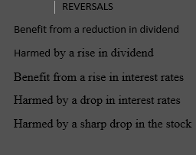

**Conversions**

Do you remember when you first learned what a long synthetic call is? It is the combination of a long put and long stock in equal measure. In other words when you are long 20 calls you would get long 2,000 shares. When you initiate a *long stock* position to hedge an existing *long put* position you have converted your long put into a long call. Your new position now benefits from an upward instead of downward move in the stock. Let’s look at the BA Sep 120 puts. Let’s say that you go long the Sep 120 puts for 3.00, and then going long the stock at 120.30. You have then created a long synthetic call for 3.30 (the premium in the Sep 120puts plus the stock price above the strike price). You can then *short* a physical BA Sep 120 *call* for 3.70. This is called a conversion. You have netted a credit of 0.40.

There’s more to the story, however. There is a thing called the broker call rate. That is the interest rate charged to customers by clearing firms for carrying a long stock position. The broker call rate is 2 %. You are charged that debit on a pro rata basis. The position is established 43 days prior to expiration. Here is the formula used to figure out long stock interest: (strike price X broker call rate) X (#days ‘til expiration/360) = debit. For this example, it would be: (120 X 2.0%) X (43/360) = 0.29. The debit of 0.29 is matched up with the credit of 0.40 for a total credit of 0.11.

Look at the BA Jan 120 conversion. You go long the Jan 120 puts for 6.70 while going long the stock at 120.35. You have then created a long synthetic call for 7.05 (the premium in the Sep 120 puts plus the stock price above the strike price). You can then short a physical BA Jan 120 call for 7.55. You have netted a credit of 0.50.

This position is established 161 days prior to expiration. For this example, it would be: (120 X 2.0%) X (161/360) = 1.08. The broker call rate is 2.0%. The credit of 0.50 is matched up with the 1.08 debit for a total debit of 0.58. So, who needs deals like this? That’s not quite the whole story. Unlike the Sep conversion, the Jan conversion deals with the quarterly dividend in BA that occurs in early November. The dividend is 0.73. A 0.15 credit, while not a bonanza, is not exactly chicken liver.

Here is the complete formula used to figure out the conversion: (strike price X broker call rate) X (#days ‘til expiration/360) + dividend = credit or debit. Have you noticed that there is another way to look at the conversion? When you combine the short Sep 120 call@3.70 with the long stock at 120.30 you have created a synthetic short put for 3.40 (the time value embedded in the 3.70 premium for the 120 calls). When you combine that with the long Sep 120 physical put for 3.30 you wind up with the same credit of 0.10. When you go short the BAJan120 call for 7.55 while going long the stock at 120.35 you have created a short synthetic put for 7.20. When you combine that with the short Jan 120 physical call for 6.70 you wind up with the same debit of 0.50.

Here is a review a of *conversions*. When a firm *reduces* their *dividend* that’s a *minus* for the position. When *interest rates rise* that is also a *minus* for the position. Conversely when there is a *rise* in the *dividends* and/or a *decline in* *interest rates* that is a *plus* for the position. Another factor that would be a *plus* for a conversion is a *sharp drop* in the *price* of the underlying stock. Why is that the case? When you are long a deep ITM put you are paying interest on your long position. BA Jan 120 puts is an example. BA drops from its current price of 120.35 to 80.00 on November 15th. The ex-dividend date happened a week earlier so paying out the dividend would not be an issue. In that case you would be wise to exercise your put and stop paying interest on your long stock position. In addition, you could buy back your BA Jan 120call for next to nothing.

Is there any *remedy* for a trader with an existing *reversal* position who *fears* that their *short puts will be assigned* when the underlying *stock keeps going down*? Let’s take the example of the IBM Dec 185 reversal. What if you could buy back your stock sell your long calls and buy in your short puts while going long the IBM Dec 175 calls, shorting the IBM Dec 175 puts and shorting IBM common for a slight debit? Would it be worth it? What have you done? You have gone *long the* Dec 185-175 *box*. There is no need to trade any stock. What price would you pay for the box? If you were afraid of losing out on 0.25 in interest, you most certainly would pay at least 10.10 for the box.

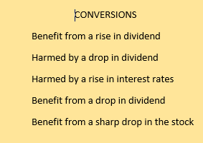

**Jelly Rolls**

Conversions and reversals have a bid/ask spread. Take the example of the BA Dec120 conversion/reversal market. This is how you figure it out: reversal = (43/360) X (1.6% X 120) = 0.2304; conversion = (43/360) X (2% X 120) = 0.288. There is no dividend involved here. The dividend wouldn’t make any difference since they would cancel each other out. You would establish a reversal position for a debit of 0.23 and establish a conversion for a credit of 0.29. What would the market be if the broker call rate rose to 8%? The reversal (43/360) X (6.4% X 120) = 0.9173, while the conversion (43/360 X (8% X 120) = 1.146. The reversal/conversion market would be 0.91/1.15. The width of the bid/ask, spread 0.24 vs. 0.06, exactly four times as wide. It stands to reason that there is a much more robust trade with higher interest rates. It is an even better market when interest rates are rising and falling.

Look at an existing reversal and see if it is worth rolling forward. How would you go about doing this? A *reversal* is a position of *long call*, *short same strike and expiration cycle put* and *short stock*. Look specifically at the IBM Sep 185 reversal. If you roll it forward through the Oct expiration you will be collecting an extra 28 days of short stock rebate. The ex-dividend date for IBM is not until November so that will not be an issue. How much rebate will be accrued for an extra 28 days? That would be (1.6% X 185) X (28/360) = 0.23. If you can pull it off for less than 0.23 then it might be worth it.

How do you accomplish it? You first need to buy in your short IBM Sep 185 puts and the sell out your long IBM Sep 185 calls. You would then go long IBM Oct 185 calls and short IBM Oct 185 puts. You go long the IBM Oct – Sep 185 call spread and then short the IBM Sep – Oct 185 put spread. You go long the Oct 185 calls for 6.90 and sell out the long Sep 185 calls for 5.05 (1.85 for the call spread). Next you buy in the short Sep 185 puts for 3.35 and short the Oct 185 puts for 5.05 (1.70 for the put spread).

Look at an existing conversion and see if it is worth rolling forward. How would you go about doing this? A *conversion* is a position of *long put, short same strike and expiration cycle call* and *long stock*. Look specifically at the BA Sep 120 conversion. If you roll it forward through the Oct expiration you will be paying an extra 28 days of interest. The ex-dividend date for BA is not until November so that will not be an issue. How much long interest will be accrued for an extra 28 days? That would be (2.0% X 120) X (28/360) = 0.19. If you generate a credit greater than 0.19 then it might be worth it.

How do you accomplish it? You first need to buy in your short BA Sep 120 calls and the sell out your long BA Sep 120 puts. You would then go long BA Oct 120puts and short BA Oct 120calls. You go long the BA Oct – Sep 120put spread and you go short the BA Sep – Oct 120 call spread. You go short the Oct 120 calls for 4.85 and buy in the short Sep 120 calls for 3.65 (1.20 credit for the call spread). Next you sell out your long Sep 120 puts for 3.05 and go long the Oct 120 puts for 3.95 (0.90 for the put spread).

That is 0.12 in your favor. Even when you are not rolling forward a position, would it be worth initiating a position at those prices? The answer is yes. When you are trading the jelly roll for your reversal you are creating the equivalent of a short stock position. Either your short calls will finish ITM and be assigned or your long puts will finish ITM and be exercised. Either way you will be short stock for the 28 days. When you are trading the jelly roll for your conversion you are creating the equivalent of a long stock position. Either your short puts will finish ITM and be assigned or your long calls will finish ITM and be exercised. Either way you will be long stock for the 28 days.

**Skewness,Front Spreading& Back Spreading**

Skewness occurs when a set of data is asymmetrical and therefore not an example of a normal distribution. Look at some options data and we’ll determine positive and negative skewness. Look at the SPY Nov 205 calls at 0.89 and Nov 181 puts at 2.95. SPY is currently marked at 193.24. These calls and puts are roughly equidistant from the price of the underlying ETF. The puts are 12.24 OTM while the calls are 11.76 OTM yet the puts are more than triple the price of the calls. Why is that the case? Does this mean that SPY is more likely to drop in price than rise in price? That would be an intelligent guess but a wrong one. What it does mean is that SPY moves much more rapidly when it is heading south than it does when it is heading up. In other words, it might take five weeks for SPY to get to 205 but it might take only three days to drop to 181. During that five, week trek up to 205 there will be plenty of decay in the time value of the 205 calls. Three days to the downside is not much of a burn rate. Look at the IVOL in the strike prices from 186 to 200. They are 16.7, 16.4, 16.2, 15.9, 15.6, 15.3, 15.00, 14.7, 14.4, 14.1, 13.8, 13.4, 13.2 and 12.9. SPY is positively skewed to the downside and negatively skewed to the upside.

SPY is the ETF that represents the 500 stocks in the S & P 500. It, therefore, accurately measures the composite IVOL and skewness in those stocks. There are huge arbitrage funds that make sure that it does. Over 95% of stocks in the S & P 500 are negatively skewed to the upside and positively skewed to the downside. That skew is considered normal. Here are two strategies that take advantage of a normal skew. One is an OTM call ratio front spread. Another is an OTM put ratio back spread.

Look at the OTM call ratio front spread. The best time to establish this position is when the IVOL is clearly above average. After a sharp sell-off where the IVOL pops works best. Look at the BA Nov 125-130 5 X 8 call spread. For each 5 X 8 spread there is a negative 10 deltas. There is a negative 40 vega. If BA runs up the IVOL would drop and the position would profit. There is a debit of 1.90 so if BA falls out of bed that is the most that will be lost despite the certain rise in IVOL. The skew indicates that it is unlikely that there would be a gap move to the upside. The slow move to the upside would allow you to adjust your position as the stock went up.

Look at the OTM put ratio back spread. The best time to establish this position is when the IVOL is clearly below average. Look at the BA Jan 105-115 2 X 1 put ratio back spread. A back spread is an options position where you have a net long options position. Because a back spread is net long options there is a defined risk in the position. This position can be established for a credit of 0.35. When BA keeps heading upward then you can pocket the small credit. That is not, however the reason to establish this position. At expiration the dead zone for this spread is 105. Your long options are worthless while your short options are worth 10. It is a delta neutral spread that gives you a positive vega of 13 for each 2 X 1 the trade is made. A 40 X 20 spread would yield a positive vega of 260. If BA drops suddenly from 120.50 to 115.50 you can bet that there will be a significant pop in IVOL and a resulting rise in profitability.

There are stocks that have a *flat skew*. They are *not positively or negatively skewed*. This means that the *speed* with which they *move* is roughly *equal* whether the *stock* is going *up or down*. This means that there is no advantage when you are trading ratio spreads in these stocks. This does not mean that you cannot either front spread or back spread these stocks. Stocks such as AAPL, GOOG, TSLA and BIDU are stocks where the OTM puts and calls are similar in price. These stocks are relatively new and extremely volatile. They go up as rapidly as they go down.

Going long a straddle or a straddle is back spreading. *Back spreads* are usually *net long options*. A *back spread* is usually a *positive vega*, *positive gamma* and *negative theta* position. A *rise* in the *volatility* of the stock (and the subsequent rise in IV) is very *beneficial* to the position’s profitability.

Going short a straddle or is front spreading. *Front spreads* are usually *net short options*. A *front spread* is usually a *negative vega*, *negative gamma* and *positive theta* position. A *drop* in the *volatility* (and the subsequent drop in IV) of the stock is very *beneficial* to the position’s profitability.

**MAJOR EVENTS**

The most common major event when trading options on stocks is the quarterly earnings report. The IVOL for options that expire before an earnings report are lower than the options that will still be in play when earnings are announced. Look at GOOG. Their earnings report comes out after the close on October 16th. Expiration Friday is the next day. The stock is currently trading at 562.50. The GOOG Aug 560 calls, which are expiring in four days, have an IVOL of 19.8. The Sep 560 calls, expiring in 39 days, have an IVOL of 20.5. The Oct 560 calls, expiring in 67 days, have an IVOL of 24.0. That is a big difference in a highly priced stock. The expiration cycle that is the closest to expiring while still in existence during the release of earnings will have the highest IVOL. That makes a lot of sense. If the general options public believes that there will be a big move after the release of earnings it makes sense to establish a long position that has the least amount of time value. If there is a major move those options will be deep ITM and therefore lose their time value. If there is not a big move, then you at least are not holding as much time value. One way to take advantage of that situation is to short the nearest expiring option and go long options a month away. You establish a positive vega position where you hope the stock does not move and the IVOL crashes. This anomaly occurs when the soon to expire option has a radically higher IVOL than the rest of the expiration cycles.

An example of earnings on steroids is a biotech stock with an upcoming FDA announcement. This can be a make or break situation for the underlying stock. Some of the time, the FDA will kick the can down the road, regarding their announcement. When you are short the IVOL you can clean up.

Another major event is a potential takeover. If there is a cash take over the time value will disappear in every expiration cycle. When you want to fade a potential takeover in a stock you could go long time value spreads. If the rumor persists over an extended time frame then it can be a very profitable strategy as the time value spread blows up as it nears the end of the expiration cycle.

If you are trading options on agricultural products such as corn, soybeans, or wheat the monthly USDA report keeps the IVOL propped up until the numbers come out. The IVOL will drop after the report, but that does not mean that you’ll profit when it does that. The futures might make such a big move that the drop in IVOL will be irrelevant.

Another major event is ex-dividend day. When you are short stock at the end of that day you pay out the dividend and when you are long stock on that day you will receive the dividend. You go long an IBM Dec 185 call. IBM then rises to 233.20 on November 6th, the ex-dividend day. The IBM Dec 185 puts are offered at 0.30. It would then make sense for you to exercise the calls and capture the $1.10 dividend. You would be debited 0.44 for the long interest in carrying your stock until Dec expiration. That works out to be a profit of 0.36.

The first four things that I look at when deciding to trade options in a stock are the liquidity, skew, the earnings date and the ex-div date.

**EXOTIC OPTIONS**

The listed options that are traded on exchanges are vanilla options. Vanilla options are either European or American style options. American style options can be exercised at any time leading up to expiration. European options are exercised at expiration. Exotic options are traded over the counter (OTC). The various exotic options covered here are barrier options, Asian options, lookback options, compound options, rainbow options, mountain range options and binary options.

**Barrier Options**

Barrier options have a “knock-in” and a “knock-out” feature. They become activated when they reach a certain (knock-in) price. The other barrier option starts out active and gets knocked out at a certain point.

Up-and-in and Down-and-in options are knock-in options. With an up-and-in option the price of the underlying begins below the barrier level and need to move up to have the option knocked in. BIDU is trading at 216 and the barrier is set at 230. Your premium will be lower than a vanilla 230 call. After all you can still make money on an option that never goes ITM. With a down-and-in option the price of the underlying begins above the barrier level and needs to move down for the option knocked in. BIDU is trading at 216 and the barrier is set at 200. Your premium will be lower than a vanilla 200 put.

Up-and-out and down-and-out options are knockout options. With an up-and-out option the underlying begins below the barrier level. BIDU is trading at 216 and the barrier is set at 230. When BIDU hits 230 your call is knocked out for good. Your premium will be lower than a vanilla 230 call as a result. With a down-and-out option the underlying starts out above the barrier level. Once it moves down to the barrier level (200) it is knocked out for good. This is cheaper than a vanilla 200 put.

**Asian Options**

With Asian options the price of the underlying is not the price that determines the value of an option at expiration. The average price over a specific time is substituted. This reduces the volatility of the option and therefore reduces its premium.

**Lookback Options**

Lookback options allow the holder of the option to look back over a certain time frame so that you can choose the best price over that time frame to be the price at expiration. Lookback options have both floating strike prices and fixed strike prices.

ADVANCED OPTIONS QUIZ

1. Regarding options ESP refers to _______________________.
2. extra sensory perception
3. extra special puts
4. equivalent scalping position
5. equivalent share position
6. An ATM put would have a delta close to
7. 0.50
8. -0.50
9. 0.25
10. -0.25
11. Gamma is always a __________________ number.
12. positive
13. negative
14. neutral
15. magic
16. Theta is always a __________________________ number.
17. positive
18. negative
19. neutral
20. magic
21. Vega is always a ________________________________ number.
22. positive
23. negative
24. neutral
25. magic
26. Rho is always a ___________________________ number.
27. positive
28. negative
29. neutral
30. magic
31. Gamma is always at its highest when it is ______________________.
32. OTM, far away from expiration
33. ITM near expiration
34. ATM, far away from expiration
35. ATM, near expiration
36. An OTM long call time value spread is _________________ deltas.
37. neutral
38. negative
39. positive
40. flexible
41. An OTM long put time value spread is ___________________ deltas.
42. neutral
43. negative
44. positive
45. flexible
46. A long straddle is _____________________ gamma.
47. flexible
48. negative
49. neutral
50. positive
51. A short strangle is__________________________ gamma.
52. flexible
53. neutral
54. positive
55. negative
56. A long, time value spread is _____________________ vega.
57. flexible
58. neutral
59. positive
60. negative
61. An increase in IVOL will benefit a ___________________ vega position.
62. flexible
63. neutral
64. positive
65. negative
66. An increase in IVOL means a ________________________ in theta.
67. decrease
68. melting
69. freezing
70. rise
71. An increase in interest rates _________________ a positive rho position.
72. does not affect
73. benefits
74. hurts
75. none of the above
76. An OTM put ratio spread is a ___________________ spread.
77. side
78. smooth
79. front
80. back
81. An OTM call ratio spread is a ___________________ spread.
82. side
83. smooth
84. front
85. back
86. An OTM call ratio spread is a _____________________ vega position.
87. flexible
88. neutral
89. negative
90. positive
91. An OTM put ratio spread is a _______________________ vega position.
92. flexible
93. neutral
94. negative
95. positive
96. When you go long an IBM Oct 195 synthetic put and sell an IBM Oct 195 put against it you have created a ____________________.
97. reversal
98. conversion
99. inversion
100. diversion
101. A reversal is ___________________ by a rise in interest rates.
102. not affected
103. hurt
104. not concerned
105. helped
106. A conversion is _____________________ by a rise in the dividend.
107. not affected
108. hurt
109. not concerned
110. helped
111. The movement in the price of a stock affects a reversal negatively when it makes a ______________________.
112. mild rise
113. sharp rise
114. mild drop
115. sharp drop
116. When there is a rise in the price of the stock in a positive gamma position what happens to the deltas?
117. neutral effect on deltas
118. more positive deltas acquired
119. more negative deltas acquired
120. deltas go in a circular fashion
121. When there is a drop in the price of the stock in a negative gamma position what happens to the deltas?
122. neutral effect on deltas
123. more positive deltas acquired
124. more negative deltas acquired
125. deltas go in a circular fashion
126. For the most stocks, the options are _______________________.
127. positively skewed to the upside and negatively skewed to the downside
128. neutral skew to the upside and negatively skewed to the downside
129. negatively skewed to the upside and neutral skew to the downside
130. negatively skewed to the upside and positively skewed to the downside
131. When a stock is negatively skewed to the upside while being positively skewed to the downside that means that the stock ___________________________.

a) moves more rapidly to the downside than the upside

b) moves more rapidly to the upside than the downside

c) moves equally rapidly to the upside and downside

d) will more likely move down in price than up in price

28) When a stock has a flat skew, it means that the stock _______________________.

a) moves more rapidly to the downside than the upside

b) moves more rapidly to the upside than the downside

c) moves equally rapidly to the upside and the downside

d) will more likely move down in price than up in price

29) When a call is deeply ITM its delta approaches

a) 0.50

b) – 0.50

c) 1.00

d) – 1.00

30) When a call option has a 0.50 delta and the stock rises 0.50 the premium

a) drops 0.50

b) rises 0.25

c) rises 0.50

d) drops 0.25

31) When you are long the IBM Sep 195 straddle with IBM @195 your deltas are approximately

a) neutral

b) positive

c) negative

d) none of the above

32) When you collar a long stock position you have

a) taken all of the risk out of your position

b) converted your position into a short vertical put spread

c) converted your position into a long vertical call spread

d) either b or c

33) A long options position is

a) neutral gamma

b) negative gamma

c) swirling gamma

d) positive gamma

34) The risk management tools that options traders use are called the

a) Romans

b) Greeks

c) Phoenicians

d) Egyptians

35) Exotic options that are based on the price of the underlying over a specific time frame instead of the price at expiration are called ________ options.

a) American

b) European

c) African

d) Asian

36) Options that become activated when they hit a certain price are called

a) vanilla options

b) barrier options

c) tranche options

d) decisive options

ADVANCED OPTIONS ANSWER KEY

1. d

Although extra sensory perception would come in handy

1. b

Puts always have a negative delta and an ATM option has a 50% chance of finishing ITM at expiration.

1. a

When you are short options your position is negative gamma but gamma itself is always positive.

1. b

When you are short options your position is positive theta but theta itself is always a negative number.

1. a

When you are short options, particularly the back months, your position is negative vega but vega itself is always a positive number.

1. a

When you are short options your position is negative rho but rho itself is always a positive number.

1. d

Gamma is a derivative of delta that measures how much delta increases or decreases so at expiration it is either a 100 delta or a zero delta.

1. c

When the underlying approaches the strike price the position becomes more delta neutral. Originally the near term OTM short calls provide very little negative deltas.

1. b

When the underlying approaches the strike price the position becomes more delta neutral. Originally the near term OTM short puts provide very little positive deltas.

1. d

As the stock rises positive call deltas rise while negative put deltas sink. The opposite occurs as the stock goes down.

1. d

As the stock rises negative call deltas rise while positive put deltas sink. The opposite occurs as the stock goes down.

1. c

Vega measures the amount of time value in your position. There is more time value in the further out options.

1. c

An increase in IVOL means that the time value in options has increased.

1. d

The increase in time value means that there is more for it to decay

1. b

An interest rate hike would mean that profitability would ensue

1. d

Back spreads are positive gamma positions that are usually net long options.

1. c

Front spreads are negative gamma positions that are usually net short options.

1. c

An OTM call ratio spread is net short options and benefits from a drop in IVOL.

1. d

An OTM put ratio spread is net long options and benefits from a rise in IVOL.

1. a

A reversal is a long call, short put at the same strike and expiration cycle and short the stock.

1. d

An increase in interest rates means an increase in short stock rebate.

1. d

A conversion is a long put, short call at the same strike price and expiration cycle and long the stock. The long stock collects the dividend.

1. d

When there is a sharp enough drop in the price your short puts might be assigned and you lose out on the short stock rebate.

1. b

Gamma measures the increase in delta with an incremental move in the stock.

1. b

Short gamma positions acquire positive deltas to the downside and negative deltas to the upside.

1. d

Equidistant OTM put premium is higher than equidistant OTM call premium.

1. a

When the historical volatility indicates rapid downward moves and slow upward moves then there will be more time value embedded in the OTM puts than the OTM calls.

1. c

When there is a flat skew there is neither an upward nor a downward bias in the historical volatility.

1. c

Deep ITM options move in tandem or near tandem with the underlying.

1. b

When the underlying moves 1 point and you have a 0.50 delta the premium increases by 0.50. When the underlying moves half as much then the premium moves half as much.

1. a

The ATM call should have a delta of 0.50 and the ATM put should have a delta of -0.50.

1. d

With a collar you are going long a protective put while shorting a call to help finance it. The protective put is equivalent to a long call. Another way to look at it is that you are writing a call and then going long the put.

1. d

As the underlying increases so does the delta. Conversely, as the underlying decreases so does the underlying.

1. b

That is probably because of a familiarity with Greek letters.

1. d

American options can be exercised at any time. European options can be exercised only at expiration. There are not any African options

1. b

Barrier options “knock in”, or come into existence, when they reach a certain level.